HO CHI MINH CITY PEOPLE'S COMMITTEE
SAIGON UNIVERSITY



PROJECT
SOFTWARE TESTING
TOPIC: FURNITURE TRADING WEBSITE

Instructor: Do Nhu Tai
Student Group:
Le Duy Tin – 3122411211
Nguyen Huu Anh Khoa - 3122411098
Đo Tan Loc - 3122411115
Vo Van Luan – 3122411120
Class: DCT122C3

Ho Chi Minh City – 2025
Table Of Content
PREFACE 6
CHAPTER 1: INTRODUCTION TO THE TOPIC 7
1. Overview 7
2. Requirements Analysis 7
2.1. Current State Survey 7
2.2. Business Context 7
2.3. Business Requirements 9
3. Project Objectives 13
3.1. Development Objectives 13
3.2. Software Testing 14
3.3. Agile Testing Process and CI/CD 15
3.4. Technologies Used 17
4. Implementation Plan 18
4.1. Development Plan 19
4.2. Testing Plan 20
CHAPTER 2: SYSTEM DESIGN AND ARCHITECTURE DESIGN 23
1. System Design 23
1.1. Functional Analysis 23
1.2. Data Analysis 45
1.3. Interface Analysis 56
2. System Design 61
2.1. Block Diagram 61
2.2. Decomposition View 61
2.3. Communication View 67
2.4. Deloyment View 72
CHAPTER 3: TEST PLAN 73
1. Introduction 73
1.1. Purpose 73
1.2. Context 73
1.3. Scope 73
1.4. Risk List 77
2. Items to be Tested 78
2.1. Functional 78
2.2. Usability 79
2.3. Performance 79
2.4. Compatibility 80
3. Items Not to be Tested 80
3.1. Third-party System Functions 80
3.2. Advanced Security Testing 80
3.3. In-depth Usability Testing 80
4. Acceptance Test Criteria 81
4.1. Test Coverage 81
4.2. Test Case Pass Rate 81
4.3. Number of Test Cases 81
4.4. Unit Test Density 82
4.5. Source Code Coverage 82
4.6. Number of Defects 82
4.7. CI/CD Process 84
5. Test Strategy 85
5.1. Test Methodology 85
5.2. Types of Testing 85
5.3. Testing Level 87
6. Test Execution Plan 88
7. Test Environment 89
7.1. Hardware 89
7.2. Software 90
7.3. Infrastructure 90
8. Deliverables 91
CHAPTER 4: TESTING METHODS 92
1. Introduction 92
2. V-Model Test Design Process 92
2.1.Requirements & Acceptance 93
2.2. System Analysis and System Testing Planning 94
2.3. Architectural Design and Integration Testing 95
2.4. Detailed Design and Unit Testing 98
3. Test Design Techniques 100
3.1. Black-Box Testing 100
3.2. While-box Testing 107
4. Manual and Automation Testing 111
4.1. Manual Testing 111
4.2. Automation Testing 112
CHAPTER 5: REPORTING AND CONCLUSION 114
1. Testing Overview 114
2. Test Case Report 114
3. Defect Report 117
3.1. Defect Statistics by Severity 117
3.2. Detailed Defect Log 118
3.3. Detailed Root Cause Analysis and Remediation Methodology 122
4. General Conclusion 124
4.1. System Maturity 124
4.2. Existing Challenges 125
4.3. Deployment Readiness Assessment 125
4.4. Development and Optimization Roadmap 125

List Of Tables
Table 1 : Functional Requirements 9
Table 2 : Non-Functional Requirements 12
Table 3 : Technologies Used 17
Table 4 : Development Plan 19
Table 5 : Aggregate Roots 44
Table 6 : Context Mapping 44
Table 7 : Table: User 52
Table 8 : Table: Cart 52
Table 9 : Table: Product 53
Table 10 : Table: Order 54
Table 11 : Table: Category 55
Table 12 : Table CartItem 55
Table 13 : Bảng OrderDetails 56
Table 14 : List of APIs 70
Table 15 : Risk List 78
Table 16 : Types of Testing 86
Table 17 : Testing Level 88
Table 18 : Testing Matrix 89
Table 19 : Human Resources 90
Table 20 : Hardware 91
Table 21 : Software 91
Table 22 : Infrastructure 92
Table 23 : Deliverables 92
Table 24 : Examples of Integration Testing 100
Table 25 : Unit Testing Strategy 102
Table 26 : User Account State Management 104
Table 27 : Order Status Management (Order Workflow) 105
Table 28 : Shopping Cart Status Management (Cart State) 106
Table 29 : Full Decision Table 107
Table 30 : Reduced Decision Table 108
Table 31 : primary functional modules 117
Table 32 : Defect Statistics by Severity 120
Table 33 : Detailed Defect Log 120

List Of Images
Image 1 : Context Diagram 24
Image 2 : Product Discovery Process 26
Image 3 : Purchase Process 28
Image 4 : Payment Process 30
Image 5 : System Management Process 31
Image 6 : Actors Involved in the GoShop System 32
Image 7 : Use Case Summary 34
Image 8 : Use Case: Product Management Function 35
Image 9 : Use Case: Order Management Function 35
Image 10 : Use Case: Payment Function 36
Image 11 : Use Case: Cart Management Function 37
Image 12 : Use Case: Account Management Function 38
Image 13 : Use Case: Access Management Function 39
Image 14 : Conceptual Model 45
Image 15 : Conceptual Level 47
Image 16 : Logical Level 49
Image 17 : Physical Level 52
Image 18 : Home Page Interface 57
Image 19 : Registration Interface 58
Image 20 : Login Interface 58
Image 21 : Product Catalog Interface 59
Image 22 : Product Detail Interface 59
Image 23 : Shopping Cart Interface 60
Image 24 : Checkout Interface 61
Image 25 : Account Information Editing Interface 61
Image 26 : Block Diagram 62
Image 27 : C1 diagram 63
Image 28 : C2 diagram 64
Image 29 : C3 (module-level) 65
Image 30 : C4 diagram 67
Image 31 : Communication View 69
Image 32 : Deloyment View 73
Image 33 : GitHub Actions CI Pipeline 115
Image 34 : Test Case Report Chart 119

PREFACE

In the current Industry 4.0 era, technology is constantly developing and is present in every field, from healthcare to management, and especially in business. Digital currency technologies are developing rapidly, and online delivery services are becoming an integral part of family life. Along with that, electronic payment methods are springing up rapidly, making the market picture more vibrant than ever. Nowadays, buyers do not need to buy and receive goods directly; they can purchase and pay online through e-commerce websites and receive goods via online delivery services, thereby changing the process of direct goods exchange that has existed for hundreds of years.
However, e-commerce has not yet fully touched specific trading industries such as furniture products. Understanding that problem, our group of 4 students decided to implement an e-commerce website project specializing in selling furniture products called GoShop. The website is built to be customer-friendly, enabling them to purchase furniture products without having to go directly to the store. At the same time, the website is also developed for administrators, helping them easily manage business activities, allowing the store to devise reasonable business strategies to optimize profits and revenue.
The GoShop website was implemented over a period of 15 weeks under the guidance of Dr. Do Nhu Tai. Although the project still has shortcomings, it has also achieved some expected results. This report summarizes the implementation process, analyzes the results achieved, and outlines the future development direction of the project

CHAPTER 1: INTRODUCTION TO THE TOPIC

Overview
GoShop is an e-commerce web application built with the goal of comprehensively simulating the operations of a furniture store in an online environment. The application aims to provide a convenient, intuitive, and easy-to-use shopping experience for consumers, especially in the context of strongly developing e-commerce which is gradually changing traditional shopping habits. Through GoShop, customers can easily access various types of furniture products, select, order, and pay without going directly to the store, saving time and effort

Requirements Analysis

Current State Survey
Currently, customers wishing to buy furniture products from GoShop must go directly to the store to select and purchase products. This causes significant inconvenience as customers spend time traveling without certainty of finding the desired product. Additionally, the store's financial management is currently manual, causing inconvenience in financial administration. Product management is done entirely by books, leading to unnecessary costs affecting revenue and future development plans

Business Context
The GoShop Website is built to meet online furniture shopping needs. Therefore, GoShop is constructed with basic business scenarios regarding: Product Catalog, Shopping Cart, Checkout Process, Inventory, Access Management, Payment Checking, Order Viewing, Account Management, and Detailed Order Statistics. There are two main users: the Buyer and the Administrator.
The GoShop Website is built to meet online furniture shopping needs. Therefore, GoShop is constructed with basic business scenarios regarding: Product Catalog, Shopping Cart, Checkout Process, Inventory, Access Management, Payment Checking, Order Viewing, Account Management, and Detailed Order Statistics. There are two main users: the Buyer and the Administrator.
Administrator Role: Manages and operates the entire GoShop system to ensure smooth and effective business operations. Main actions include: Product Management, Product Category Management, Order Management, Account Management, and Revenue Statistics
Detailed Business Flows:
Product Catalog: Buyers can browse products with filters (category), sort (price), and search by name. Users can view product details (height, width, brand, material, etc.). Administrators manage products, categories, and update inventory.
Shopping Cart: Buyers can add items to the cart, update quantities, or remove items. The system automatically calculates total cost, shipping fees, and promotions, and updates inventory availability.
Checkout Process: Upon confirmation, the system validates cart info, delivery address, and payment method, processing payment via Stripe. It then updates payment status and sends email confirmation.
Access Management: Supports registration/login via email/password or Google. The system checks roles to redirect users to the appropriate page (Storefront vs. Dashboard).
Account Management: Users manage personal info; Admins manage buyer accounts for security.
Order Management & Statistics: Buyers view order history; Admins view all orders and perform statistical analysis on revenue

Business Requirements

Functional Requirements

Table 1: Functional Requirements
Business Function | Requirement ID | Functional Requirement | Priority Level
Access Management (BR1) | Requirement1.1 | Allow new account registration using email/password or Google account. | High
Access Management (BR1) | Requirement1.2 | Allow login using email/password or Google account. | High
Access Management (BR1) | Requirement1.3 | Verify and determine the user's Role to redirect to the appropriate page (Shopping/Admin). | High
Categories and Products (BR2) | Requirement2.1 | Provide functionality to Browse, Filter (by category), and Sort (by price) products. | High
Categories and Products (BR2) | Requirement2.2 | Provide functionality to Search for products by name. | High
Categories and Products (BR2) | Requirement2.3 | Allow viewing Product details (including information, price, description). | High
Categories and Products (BR2) | Requirement2.4 | Allow management (add/edit/delete) of Product Categories. | High
Categories and Products (BR2) | Requirement2.5 | Allow management (add/edit/delete) of Products and update Inventory quantity. | High
Shopping Cart (BR3) | Requirement3.1 | Allow adding products to the Shopping Cart from any page. | High
Shopping Cart (BR3) | Requirement3.2 | Allow viewing, updating quantity, or removing products in the Shopping Cart. | High
Shopping Cart (BR3) | Requirement3.3 | Automatically calculate Total amount, Shipping fee, and Promotions (if any) in the Shopping Cart. | High
Payment (BR4) | Requirement4.1 | Collect and confirm Delivery information (address). | High
Payment (BR4) | Requirement4.2 | Integrate and process payment through Stripe. | High
Payment (BR4) | Requirement4.3 | Update Payment status after the transaction is completed. | High
Payment (BR4) | Requirement4.4 | Update (reduce) actual Inventory quantity immediately after the order payment is confirmed. | High
Payment (BR4) | Requirement4.5 | Send Order confirmation email to the buyer. | High
Orders and Account (BR5) | Requirement5.1 | Allow Buyers to review their purchased Orders and payment status. | High
Orders and Account (BR5) | Requirement5.2 | Allow Administrators to track all Orders in the system. | Medium
Orders and Account (BR5) | Requirement5.3 | Allow Buyers and Administrators to manage and update personal information. | Medium
Statistics (BR6) | Requirement6.1 | Provide detailed Order statistics functionality (revenue, quantity, etc.). | Medium

Non-Functional Requirements
Table 2: Non-Functional Requirements
Attribute | Code | Non-Functional Requirement | Priority Level
User Interface (UI/UX) (NBR1) | NonRequirement1.1 | The interface must be simple and easy to use. | High
 | NonRequirement1.2 | For each user type, there should be an appropriate and intuitive interface presentation. | High
Performance (NBR2) | NonRequirement2.1 | The product display page must load quickly, ensuring a smooth user experience. | High
 | NonRequirement2.2 | The system must ensure response time even with high concurrent access. | Medium
Security (NBR3) | NonRequirement3.1 | Clearly define role-based access control for buyer and administrator accounts. | High
 | NonRequirement3.2 | User information must be securely stored in the database. | High
Scalability (NBR4) | NonRequirement4.1 | The system should allow for future expansion of features and user scale. | Medium

Project Objectives

Development Objectives
The primary objective of the GoShop project is to develop an e-commerce web application specializing in furniture products, satisfying basic online shopping needs while effectively supporting store management activities. The system aims for stability, usability, and scalability. Additionally, the project allows students to apply theoretical knowledge to practice, enhance teamwork skills, and gain experience in requirement analysis, system design, and professional software development.

Software Testing
In this project, software testing is identified as a core focus to ensure the quality and stability of the GoShop system. Testing is conducted at multiple levels, including:

Unit Testing: Testing backend logic at controller and service levels.

Integration Testing: Testing interactions between system modules, especially APIs and databases.

System Testing: Testing the complete system end-to-end.

User Acceptance Testing (UAT): Validating the system against business workflows and acceptance criteria.

Automation Testing: Using Selenium for automated UI testing.

Performance Testing: Using JMeter to evaluate API performance.

Applying diverse testing approaches enables comprehensive software quality assessment.

Agile Testing Process and CI/CD
In the GoShop project, the testing process is organized and implemented in parallel with the software development process in order to continuously ensure system quality. The project team chooses to combine the Agile model with the CI/CD process so that testing is not only performed at the final stage but is integrated throughout the entire software development lifecycle. This approach helps detect defects early, reduce bug-fixing costs, and ensure that the system remains stable throughout the project execution.

Agile Process
The GoShop project is developed following the Agile methodology with short iterations (Sprints), where each Sprint focuses on completing a specific set of functionalities. From the requirement analysis stage, test scenarios are identified simultaneously with system design and feature development. This allows the team to clearly define testing criteria before implementation begins.
In each Sprint, after completing feature development, the team conducts testing to verify the correctness and compliance of the system with defined requirements. Defects are recorded, classified, and prioritized for resolution either within the current Sprint or the following Sprint. Repeated testing across development iterations enables continuous system improvement, minimizes defect accumulation, and enhances overall product quality.
Additionally, Agile facilitates timely feedback and adaptability. When requirements change or new issues arise, the team can quickly update corresponding test scenarios, ensuring that the system remains aligned with project objectives and real-world needs.

CI/CD
Alongside Agile, the GoShop project applies the CI/CD process to automate system build, testing, and deployment. Whenever there is a change in the source code, the CI system automatically executes integration processes, validation checks, and predefined test cases. This approach enables early detection of defects caused by code changes and ensures system consistency.
Continuous Integration (CI)
The Continuous Integration (CI) process in GoShop focuses on continuous code integration and testing. Each time the source code is modified or updated, the CI system automatically performs tasks such as building the application, checking syntax errors, and running predefined test scripts. As a result, defects arising during development are detected early, particularly those affecting critical functionalities such as product management, order processing, and user authentication. CI ensures that each change does not negatively impact previously stable functionalities.
Continuous Delivery/Deployment (CD)
The Continuous Delivery/Deployment (CD) process in GoShop ensures safe and consistent system deployment. After successful CI testing, the CD process allows deploying the new system version to the next environment (e.g., testing or staging). This enables the team to evaluate system behavior in conditions close to real-world usage while minimizing risks during feature updates or expansions. Deployment is only performed when all testing criteria are fully satisfied, ensuring system stability and reliability.

  - Technologies Used

Table 3: Technologies Used
Technology | Type | Description
TypeScript | Programming Language | A superset of JavaScript that adds static typing features, helping develop large-scale applications that are easier to maintain and less error-prone.
ReactJS | Frontend Library | A JavaScript library developed by Facebook for building user interfaces, particularly effective for Single Page Applications (SPA) with reusable components.
NodeJS | Backend Runtime Environment | An open-source, cross-platform JavaScript runtime environment that allows server-side execution with non-blocking I/O and high performance.
ExpressJS | Backend Framework | A minimal and flexible web framework for NodeJS that provides essential features for building web applications and APIs.
Stripe | Third-party Technology | A comprehensive online payment processing platform that enables businesses to accept online payments through easy-to-integrate APIs and tools.
MySQL | Database Management System (SQL) | An open-source relational database management system (RDBMS) using SQL to manage data.
Firebase | Backend-as-a-Service Platform | A Google platform providing services such as Realtime Database, Authentication, and Cloud Storage for mobile and web application development.
Prisma | ORM | A modern Object-Relational Mapper that enables safe and efficient database interaction using TypeScript/JavaScript with strong type safety.

Implementation Plan

Development Plan
Table 4: Development Plan
Sprint | Duration | Main Objective | Tasks | Testing Activities
Sprint 1 | Weeks 1–2 | Requirement analysis & overall design | Identify business requirements, analyze business context, design system architecture | Build test plan, define initial test cases
Sprint 2 | Weeks 3–4 | Core functionality development | Implement registration, login, and user role authorization | Unit testing for controllers and services
Sprint 3 | Weeks 5–6 | Product management | Add, edit, delete, and display furniture products | Unit testing, Integration testing (API–Database)
Sprint 4 | Weeks 7–8 | Shopping cart & ordering | Handle shopping cart and order creation | Integration testing, System testing
Sprint 5 | Weeks 9–10 | Payment & order processing | Integrate payment system and update order status | System testing, User Acceptance Testing (UAT)
Sprint 6 | Weeks 11–12 | UI & user experience | Complete UI design and optimize user flow | Automation testing (Selenium)
Sprint 7 | Weeks 13–14 | Optimization & performance testing | Optimize APIs and load handling | Performance testing (JMeter)
Sprint 8 | Week 15 | Finalization & reporting | Fix bugs, complete documentation, prepare final report | Regression testing, overall testing

Testing Plan

Testing Objectives
The primary objective of testing activities in the GoShop project is to ensure software quality by verifying business logic correctness, performance, and system reliability. Specifically, the testing objectives include:
Functional Verification: Ensure that 100% of functional requirements for Buyers and Administrators are implemented correctly according to specifications and acceptance criteria defined in the business requirements.
Technical Quality Assurance: Validate stable interactions between system architecture components and ensure accurate and consistent business workflows during integration.
Performance and Reliability Evaluation: Test system processing capability, response time, and stability of critical functionalities under real-world conditions.
Early Integration and Defect Control: Detect and resolve defects early through automated testing and Continuous Integration (CI), minimizing risks during system expansion or deployment.

Planned Testing Types
Based on project objectives and scope, the GoShop project applies the following testing types to comprehensively evaluate software quality:
Unit Testing: Testing small functional units, focusing on backend logic such as controllers and services.
Integration Testing: Testing data interaction between system modules, especially APIs and databases, to identify integration-related issues.
System Testing: End-to-end testing of the entire GoShop system for both buyers and administrators to ensure compliance with business requirements.
User Acceptance Testing (UAT): Validating system suitability based on real business workflows and predefined acceptance criteria.
Automation Testing: Performing automated UI testing using Selenium to verify major user flows, reduce manual testing time, and support regression testing.
Performance Testing: Conducting performance tests using JMeter on critical APIs to evaluate response time, load capacity, and system stability.

Implementation Approach
In the GoShop project, software testing is treated as a central activity in each Sprint and is automated through the CI/CD pipeline to ensure continuous quality control. During the CI phase, every code change triggers the testing pipeline, where unit tests and integration tests are automatically executed to validate business logic correctness and system component interactions.
At the end of each Sprint, completed features are further evaluated through system testing and automated test scenarios to ensure that all business workflows function stably and without regression. Test results at this stage serve as a critical basis for deciding whether the system can proceed to the next stage in the pipeline.
During the CD phase, deployment is only permitted when all test cases pass successfully. The system version is deployed to the Railway environment for user acceptance testing and Sprint evaluation, while also supporting periodic performance testing. This approach ensures that testing in GoShop is proactive, continuous, and plays a crucial role in maintaining system quality and reliability.

CHAPTER 2: SYSTEM DESIGN AND ARCHITECTURE DESIGN

System Design

Functional Analysis

Context Diagram
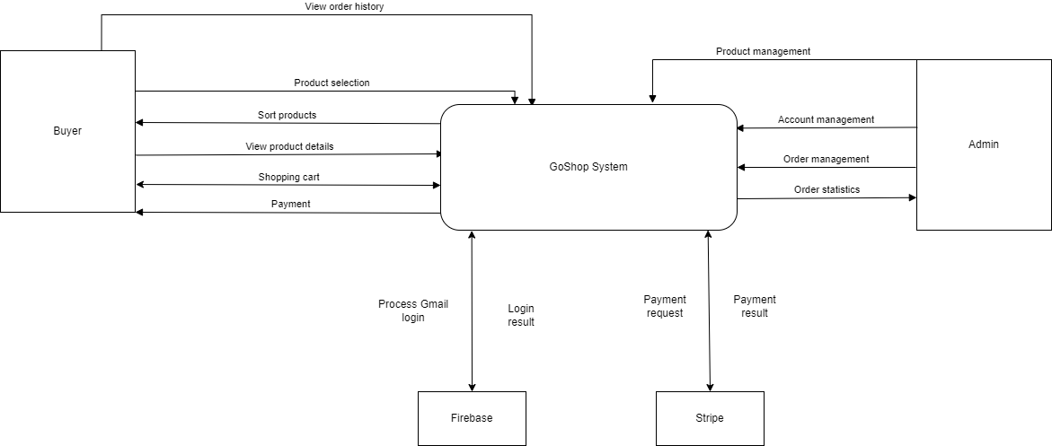
Image 1: Context Diagram
The GoShop system consists of two primary actors: Buyers and Administrators.
Buyers can register and log in to GoShop to search for products, place orders, complete payments, and view order history.
Administrators can also register and log in to GoShop; however, unlike Buyers, Administrators have access to a different interface that allows them to manage user accounts, manage orders, and view order statistics.
In addition, GoShop integrates with several third-party services:
Firebase is used to support Google Sign-In authentication for customers who wish to log in using their Gmail accounts.
Stripe is used to handle online payment processing.

Business Processes

Product Discovery Process
The product discovery process is designed to support customers who have the need to search for and explore furniture products. Customers can browse furniture items that are pre-displayed on the store’s product category pages. These category pages present products in an organized manner, allowing customers to easily view available items and compare different options.
If customers wish to search for a specific product, they can use the search bar located at the top of the website. By entering the name of the desired product into the search field, customers can perform a search while staying on the product category page. The system then processes the search request and returns a list of products that match the entered keywords.
Through this product discovery process, customers are able to efficiently locate furniture products that meet their preferences and needs, thereby improving the overall usability and effectiveness of the GoShop e-commerce system.

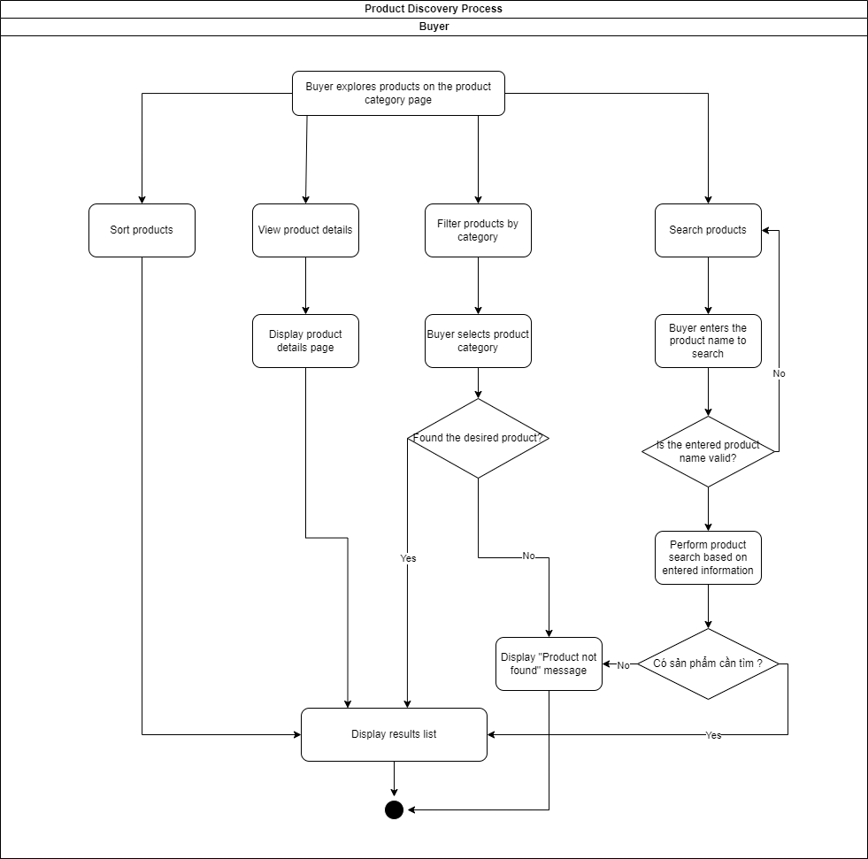
Image 2: Product Discovery Process

Purchase Process
The purchase process begins after customers have completed the product discovery phase and selected the furniture items they wish to buy. Once a desired product is identified, the customer can add the product to the shopping cart by selecting the “Add to Cart” option. This action allows the product to be temporarily stored for further review before proceeding to checkout.
Within the shopping cart, customers can view a detailed list of selected products, including product names, prices, quantities, and the corresponding subtotal for each item. Customers are allowed to adjust the quantity of each product or remove products from the cart entirely if they change their purchasing decision. The system automatically recalculates the total cost based on any modifications made to the cart contents.
After confirming the items in the shopping cart, customers proceed to the checkout stage. At this stage, customers are required to provide or verify necessary information, such as shipping details and contact information. The system validates this information to ensure accuracy and completeness before allowing the customer to move forward with the payment process.
The purchase process is designed to ensure a smooth and consistent user experience, minimizing errors and ensuring that all required information is properly collected prior to initiating payment. This structured workflow helps maintain data integrity and supports efficient order processing within the GoShop system.

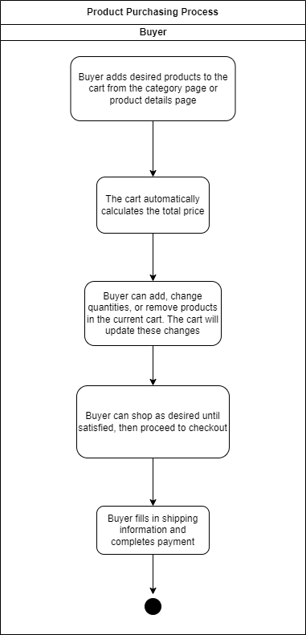
Image 3: Purchase Process

Payment Process
The payment process is initiated after the customer has successfully completed the purchase process and confirmed the items in the shopping cart. At this stage, the system collects all necessary order information, including product details, total order value, and the customer’s shipping information.
GoShop integrates with the third-party payment service Stripe to process online payments securely and efficiently. Once the customer selects a payment method and confirms the order, the system redirects the customer to the Stripe payment interface. Stripe is responsible for handling sensitive payment information and performing transaction validation in compliance with security standards.
During the payment process, the system sends the required transaction data to Stripe and waits for the payment result. If the payment is completed successfully, Stripe returns a confirmation response to the GoShop system. The system then updates the order status to indicate successful payment and records the transaction information in the database.
In the event that the payment fails or is canceled, the system updates the order status accordingly and notifies the customer so that they can retry the payment or choose an alternative payment method. No inventory changes are applied until a successful payment confirmation is received..
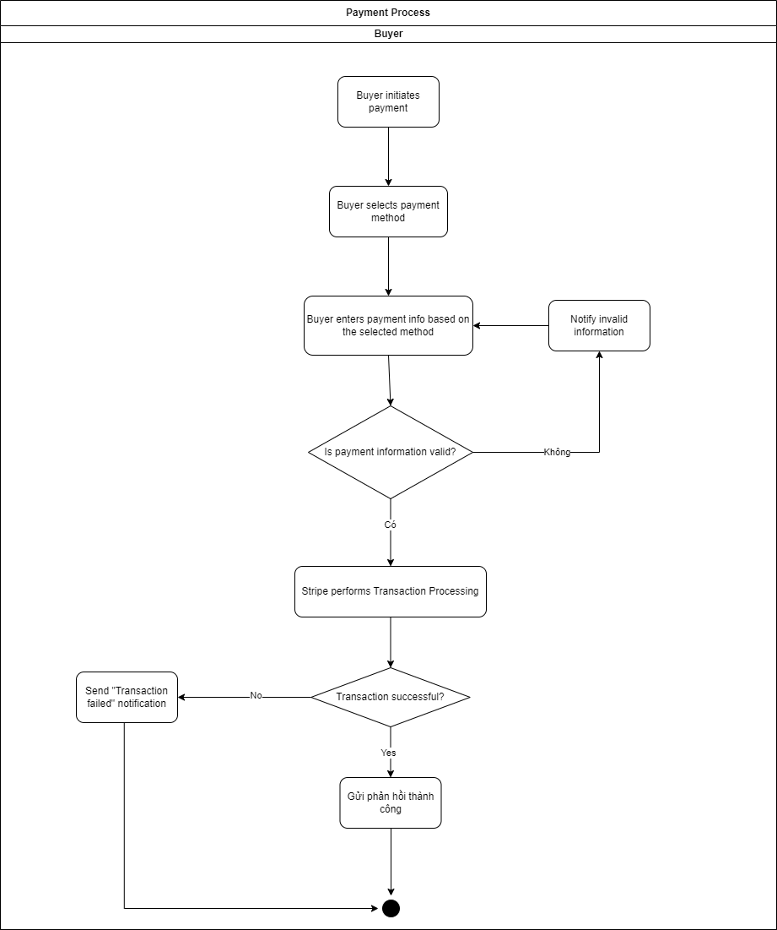
Image 4: Payment Process
      - System Management Process
The system management process supports administrators in operating and controlling the GoShop system. Administrators log in to the system using administrator accounts and are redirected to the management interface.
Through this interface, administrators can manage user accounts, manage product categories, update product information, and control inventory quantities. Administrators are also responsible for monitoring and managing orders within the system, including viewing order details and tracking order status.
In addition, the system provides statistical information related to orders and revenue. These statistics support administrators in monitoring business performance and making management decisions.

Image 5: System Management Process

Actors Involved in the GoShop System
The GoShop system involves two main actors: Customers and Administrators.
Customers focus on searching for products, selecting items, managing the shopping cart, and completing the payment process securely.
Administrators focus on managing product categories, user accounts, orders, and accessing statistical reports related to system operations and revenue.
These actors interact with the GoShop system according to their respective roles and permissions to ensure effective system operation.
.
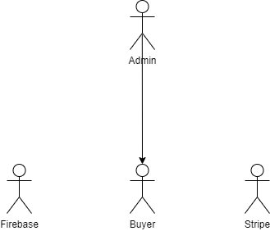
Image 6: Actors Involved in the GoShop System

Use Case
      - Use Case Summary
Buyer: Can perform the following functions: Product Management, Cart Management, Personal Account Information Management, Order Management, and Access Management.
Administrator: Can perform the following functions: Product Management, Order Management, Account Management, and Access Management.
Stripe Payment Gateway: Participates in the payment processing workflow.
Firebase: Participates in the access management workflow.
Detailed Use Cases

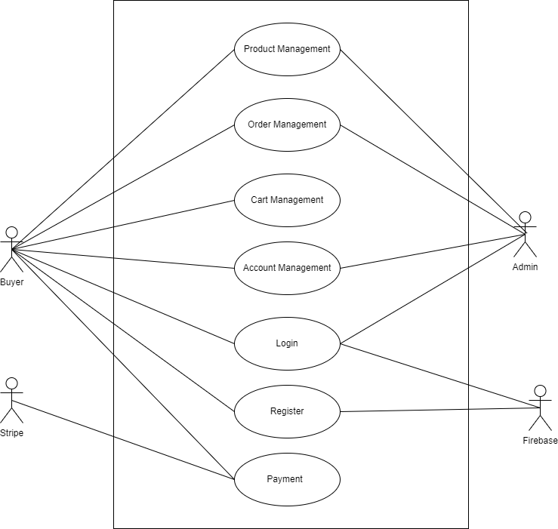
Image 7: Use Case Summary

      - Use Case: Product Management Function
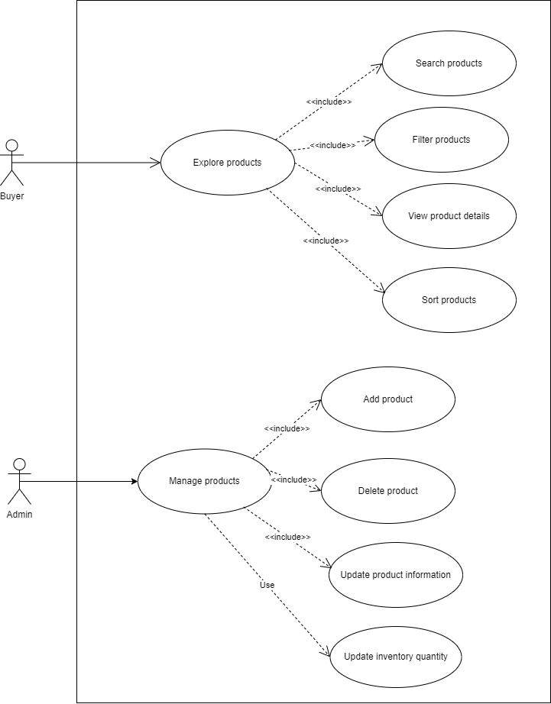
Image 8: Use Case: Product Management Function

Buyer: In the product management function, the Buyer can Search for products, Filter products, Sort, and View product details.
Administrator: Can perform actions to Add products, Delete products, Update product information, and Update inventory.
      - Use Case: Order Management Function
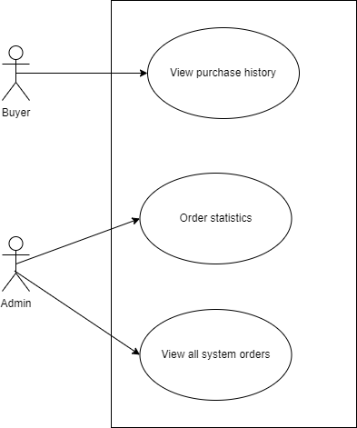
Image 9: Use Case: Order Management Function
Buyer: Can review the history of orders they have purchased.
Administrator: Can view all orders in the system and perform statistics on those orders.
      - Use Case: Payment Function
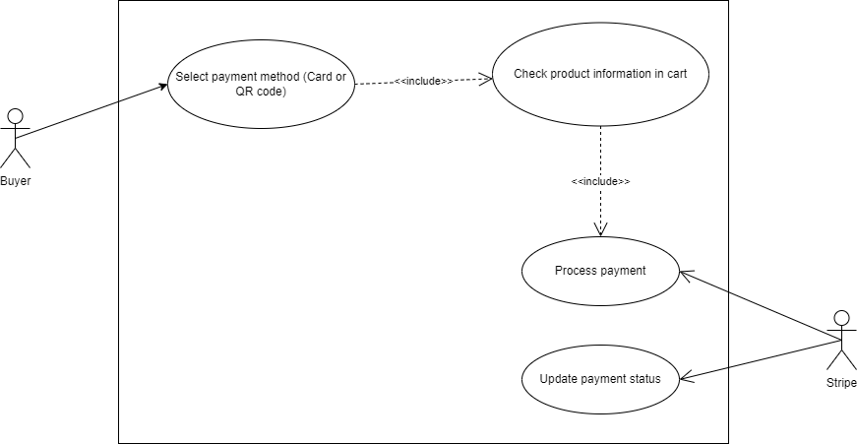
Image 10: Use Case: Payment Function
Buyer: Selects one of two payment methods: Payment via Bank Card or QR Code.
Stripe Payment Gateway: Is invoked to execute the transaction.

      - Use Case: Cart Management Function
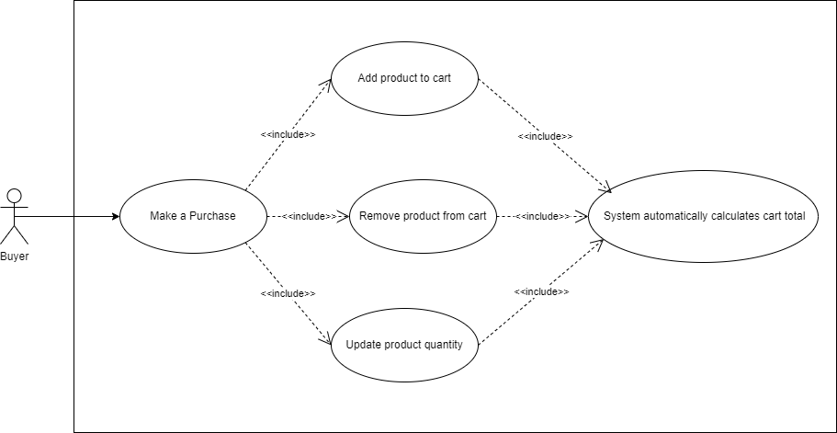
Image 11: Use Case: Cart Management Function
Buyer: Can Add, Edit, Delete, or Update the quantity of products in the shopping cart.
      - Use Case: Account Management Function
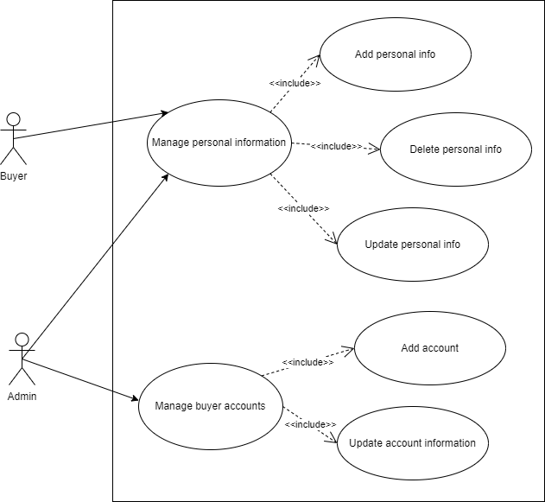
Image 12: Use Case: Account Management Function

Buyer: Can manage their own personal account information.
Administrator: Can Add, Edit, and Delete Buyer accounts, and simultaneously manage administrator account information.
.
      - Use Case: Access Management Function
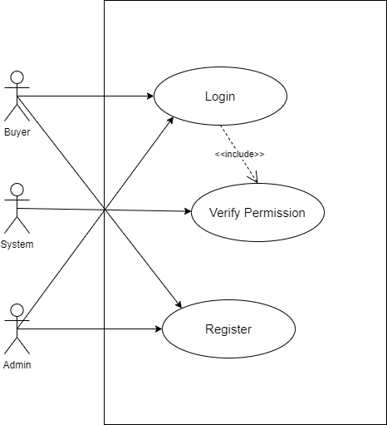
Image 13: Use Case: Access Management Function
Buyer: Can Login and Register an account to use the system.
Administrator: Can only Login to the system.

User Story
Product Management User Story
As a Buyer, I want to see a list of products with a visually appealing interface, full information, and high-resolution product images. Functions such as filtering, sorting by name or price must operate quickly and stably.
When filtering products by price or name, the product list needs to be narrowed down to suitable products.
When sorting in descending or ascending order by price or name, the product list needs to be arranged in this order.
When both filtering and sorting are performed, the product list will be effective according to both descriptions above.
As a Buyer, I want to be redirected to the product detail page with basic attributes such as name, description, inventory quantity, material, and product images.
As an Administrator, I want to manage products (CRUD) and update the inventory quantity of the product.
Order Management User Story
As a Buyer, I want to view my order history.
As an Administrator, I want to view all orders existing in the system.
As an Administrator, I want to have revenue statistics of orders to thereby have a panoramic view of the business situation.
Payment User Story
As a Buyer, I want to make payments for selected products to complete the purchase.
As a Buyer, when I start the payment process, I want the system to automatically validate product information and process the payment to ensure the transaction is executed accurately.
As a Buyer, if product information is invalid, I want the payment process to be cancelled and to receive a notification so that I know the transaction was unsuccessful.
As a Buyer, when payment is successful, I want the system to record the transaction as an order and send a confirmation email to confirm that my transaction has been completed successfully.
Cart Management User Story
As a Buyer, I can add any product currently displayed on the product catalog page to my cart. (When this product is added to the cart, by default, one product will be added).
As a Buyer, I can view product details and buy this product if desired. (When this product is added to the cart, by default, one product will be added).
As a Buyer, I want to view the list of products I just added to the current cart and want to see the information board for the current cart such as the total cost of the current cart, and promotion costs if any.
As a Buyer, I want to update the quantity of products in the cart. Whenever the product quantity in the cart is updated, the summary information board gets updated according to the changed quantity.
As a Buyer, I want to delete any product in the list of products in the cart that I no longer want to buy.
As a Buyer, when performing payment for my cart, I want it to happen quickly; in case issues arise, I expect to receive assistance from the store.
Account Management User Story
As a Buyer/Administrator, I want to manage personal information in my account.
As an Administrator, I want to manage Buyer accounts.
Access Management User Story
Every Buyer/Administrator is a User.
As a Buyer/Administrator, I want to register into the system.
As a Buyer/Administrator, I want to login into the system.
Whenever a user with the Buyer role logs into the system, the user will be redirected to the product catalog page.
Whenever a user with the Administrator role logs into the system, the user will be redirected to the Dashboard page.
As a Buyer/Administrator, I want to logout of the system.

Domian Driven Desgin
      - Bounded Contexts
The GoShop system can be divided into 4 main Bounded Contexts, based on business scenarios and user roles:
A. ACCESS & ACCOUNT Context
Purpose: Manage user information, Authentication, and Authorization of access.
Ubiquitous Language: User, Role (Buyer/Admin), Account Information, Login, Role Check.
Aggregate Root: User Account.
B. CATALOG Context
Purpose: Manage product content (detailed information, categories) and monitor inventory quantity.
Ubiquitous Language: Product, Category, Product Details (height, brand, material), Inventory Quantity.
Aggregate Root: Product.
C. SHOPPING & CART Context
Purpose: Manage the Buyer's shopping experience, including browsing, searching, and cart management.
Ubiquitous Language: Cart, Cart Item, Calculate Total, Search, Filter, Sort.
Aggregate Root: Shopping Cart.
D. ORDER & PAYMENT Context
Purpose: Manage the ordering process, payment processing, and order history tracking/statistics.
Ubiquitous Language: Order, Order Item, Order Status, Payment, Payment Check, Revenue Statistics.
Aggregate Root: Order.

      - Aggregate Roots
Table 5: Aggregate Roots
Bounded Context | Aggregate Root | Main Roles / Responsibilities
Account & Access | User Account | Ensures consistency of user roles and access states.
Catalog & Product | Product | Contains detailed product information, especially inventory quantity.
Shopping & Cart | Shopping Cart | Manages all selected items and calculates the total amount.
Order Management & Payment | Order | Manages order status, payment status, and interacts with Stripe.

      - Context Mapping
Table 6: Context Mapping
Interaction | Source Context | Target Context | Relationship Description (Rules)
Add to Cart | Shopping & Cart | Catalog & Product | The shopping cart must check the product’s inventory availability before adding the item.
Place Order | Order Management | Account & Access | Shipping address information is required from the buyer’s account.
Complete Payment | Order Management | Catalog & Product | After successful payment, the order sends a request to deduct product inventory.
Order Management | Order Management | Account & Access | Buyers can view their own order history.

Conceptual Model
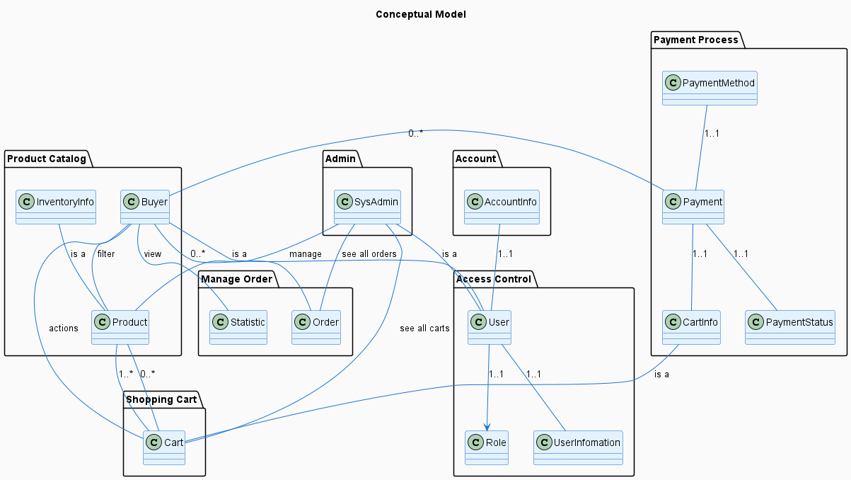
Image 14: Conceptual Model
The system is designed with a layered architecture with clear functional packages, including: Admin to manage the entire system; Product Catalog responsible for managing products, inventory, and buyer information; Shopping Cart handling cart-related operations; Access Control managing users and roles; Account managing login information; Payment Process executing payments; and Manage Order for order management.
In the data model, User is the aggregate root and has a one-to-one relationship with UserInformation, Role, and AccountInfo. From User, two entities Buyer and SysAdmin are inherited. The Buyer can view and filter products, manipulate the cart, create orders, and perform payments. Conversely, SysAdmin has the right to manage products while monitoring all carts and orders in the system. Product is linked to InventoryInfo to determine inventory quantity. Cart has a many-to-many relationship with Product, and CartInfo is an extension of Cart serving the payment process. Payment has a one-to-one relationship with PaymentMethod, PaymentStatus, and CartInfo, while Order belongs to Buyer and is monitored by SysAdmin throughout the processing lifecycle.

  - Data Analysis
    - Conceptual Level
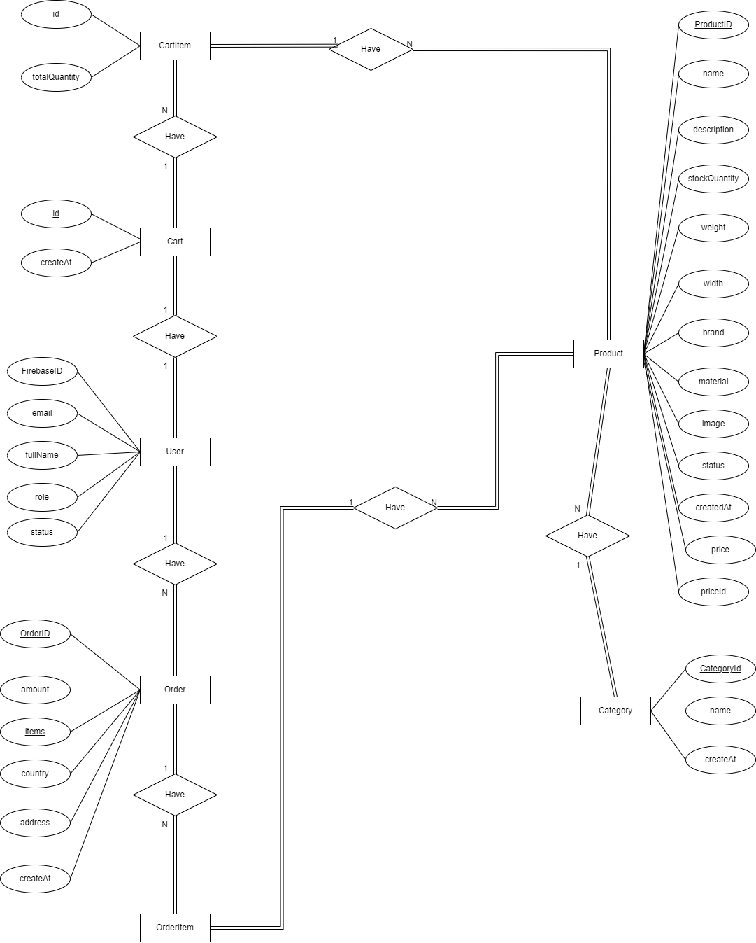
Image 15: Conceptual Level
Entity-Relationship Model (Conceptual Level) This conceptual entity-relationship model describes the main entities including User, Product, Category, Order, OrderItem, Cart, and CartItem, through the "Have" relationship.
    - Logical Level
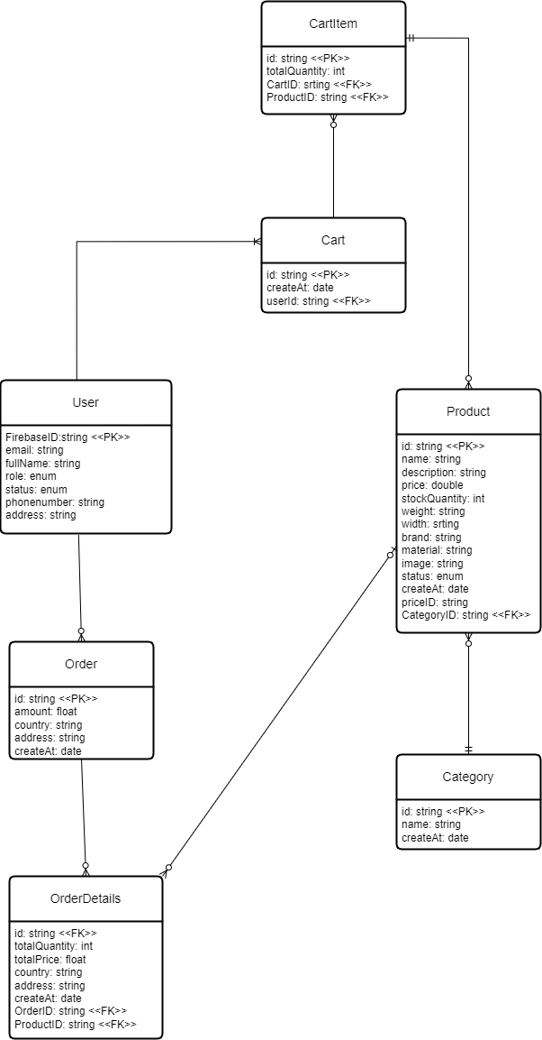
Image 16: Logical Level

The logical level model is further built from the conceptual level model. In this model, each entity from the conceptual model has been transformed into a data table with full primary and foreign keys
    - Physical Level
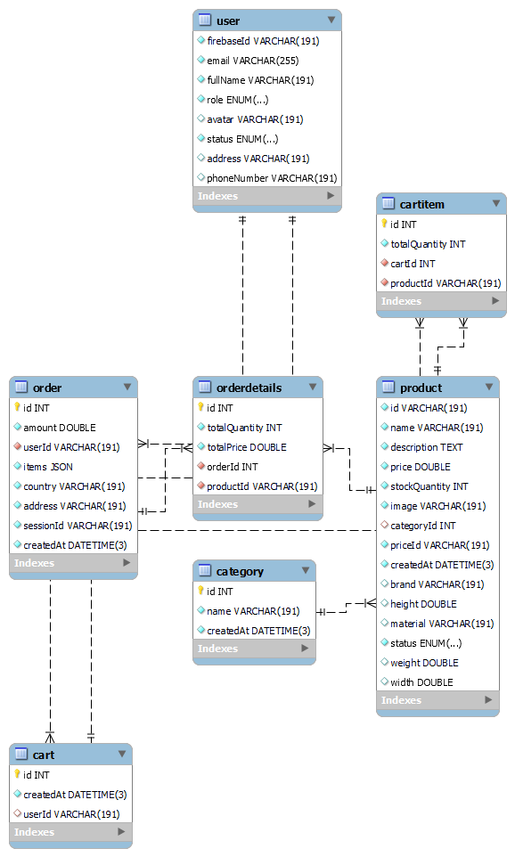
Image 17: Physical Level
The physical level entity-relationship model demonstrates the actual data structure organized within the system's database.
    - Data Dictionary
Table 7: Table: User
Attribute Name | Data Type | Description | Constraints | Example
FirebaseID | String | User identifier from Firebase | Primary Key, Unique, Not Null | u_123abcXYZ
email | String | User email address | Unique, Not Null | jane.doe@gmail.com
fullName | String | User’s full name | Not Null | Jane Doe
role | Enum(User, Admin, Manager, …) | User role | Default: "User" | Admin
status | Enum(Active, Inactive, Banned, …) | Account status | Default: "Active" | Active

Table 8: Table: Cart
Attribute Name | Data Type | Description | Constraints | Example
id | UUID / Integer | Shopping cart identifier | Primary Key | CART_00045
createdAt | DateTime | Shopping cart creation date | Default: Current Timestamp | 2025-10-22 14:23:10
userID | String | Identifier of the cart owner | Foreign Key → User.FirebaseID | u_123abcXYZ

Table 9: Table: Product
Attribute Name | Data Type | Description | Constraints | Example
id | UUID / Integer | Product identifier | Primary Key | P10023
name | String | Product name | Not Null | Yamaha Exciter 155
description | Text | Detailed product description | Nullable | 155cc sport motorcycle, fuel injection...
price | Decimal(10,2) | Product price | Not Null | 46500.00
stockQuantity | Integer | Inventory quantity | Default: 0 | 25
weight | Decimal(10,2) | Product weight (kg) | Nullable | 118.00
width | Decimal(10,2) | Product width (cm) | Nullable | 75.00
brand | String | Brand | Nullable | Yamaha
material | String | Main material | Nullable | Steel, ABS plastic
image | String | Image path | Nullable | /images/products/exciter155.png
status | Enum(Active, Inactive, Deleted, OutOfStock) | Product status | Default: Active | Active
createdAt | DateTime | Product creation date | Default: Current Timestamp | 2025-09-20 09:45:33
priceID | String | Price ID in the payment system | Nullable | price_1O2BaD3Z
categoryID | Integer | Product category identifier | Foreign Key | CAT_01

Table 10: Table: Order
Attribute Name | Data Type | Description | Constraints | Example
id | UUID / Integer | Order identifier | Primary Key | ORD_20251022_001
amount | Decimal(10,2) | Total order amount | Not Null | 93200.00
items | JSON / Text | List of products in the order | Not Null | [{"id":"P10023","qty":2},{"id":"P10031","qty":1}]
country | String | Shipping country | Nullable | Vietnam
address | String | Shipping address | Nullable | 12 Le Loi Street, District 1, Ho Chi Minh City
createdAt | DateTime | Order creation date | Default: Current Timestamp | 2025-10-22 18:05:55
userID | String | Order owner | Foreign Key → User.FirebaseID | u_123abcXYZ

Table 11: Table: Category
Attribute Name | Data Type | Description | Constraints | Example
id | UUID / Integer | Category identifier | Primary Key | CAT_01
name | String | Product category name | Unique, Not Null | Manual clutch motorcycles
createdAt | DateTime | Category creation date | Default: Current Timestamp | 2025-08-15 08:00:00
Table 12: Table CartItem
Attribute Name | Data Type | Description | Constraints | Example
id | UUID / Integer | Cart item identifier | Primary Key | CAI_01
totalQuantity | Integer | Total quantity of products | Unique, Not Null | 10
cartID | UUID / Integer | Shopping cart identifier | Foreign Key | CART_00045
categoryID | Integer | Product category identifier | Foreign Key | CAT_01

Table 13: Bảng OrderDetails
Attribute Name | Data Type | Description | Constraints | Example
id | UUID / Integer | Order item identifier | Primary Key | ORD_01
totalQuantity | Integer | Total quantity of products | Unique, Not Null | 10
totalPrice | Double | Total price of the order item | Foreign Key | CART_00045
categoryID | Integer | Product category identifier | Foreign Key | CAT_01
productID | UUID / Integer | Product identifier | Foreign Key | P10023

  - Interface Analysis
    - Buyer Interface

Home Page Interface
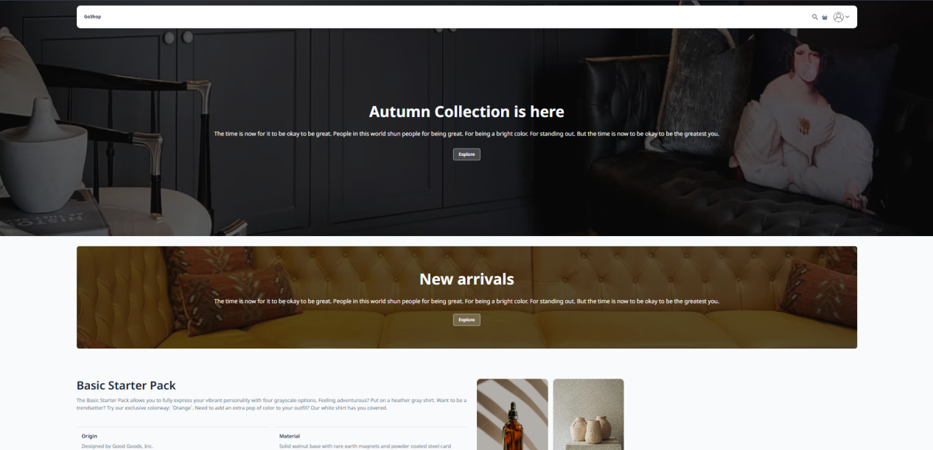
Image 18: Home Page Interface

The home page interface when the user first accesses the GoShop website

Registration Interface
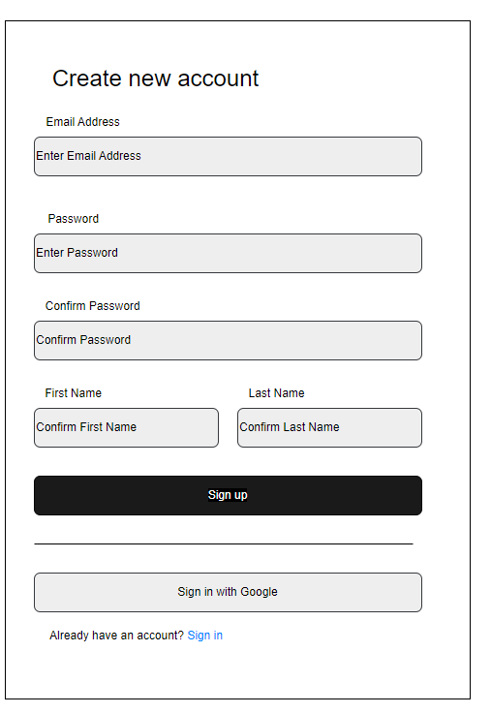
Image 19: Registration Interface

Account registration interface for buyers wishing to purchase goods on GoShop.

Login Interface
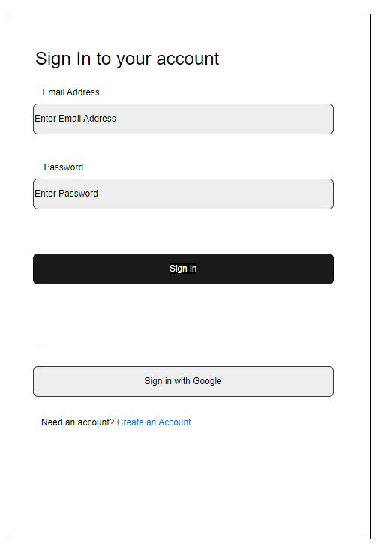
Image 20: Login Interface

Login interface for buyers if they have already registered an account.

Product Catalog Interface
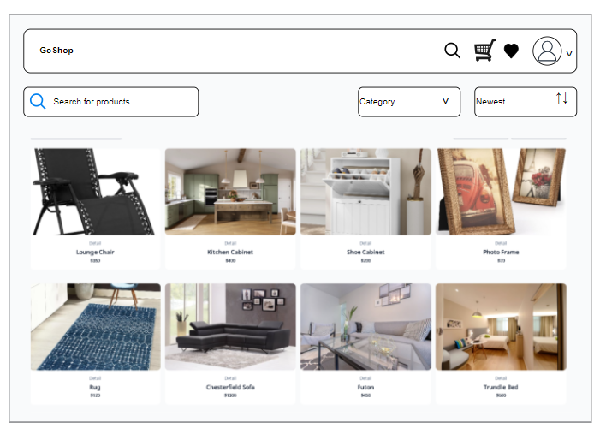
Image 21: Product Catalog Interface
The product catalog interface page displaying furniture products sold in GoShop. On the top left is the search bar, and on the right, from outside in, are the product filter by category and the umbrella box to activate the product sorting function by price.

Product Detail Interface
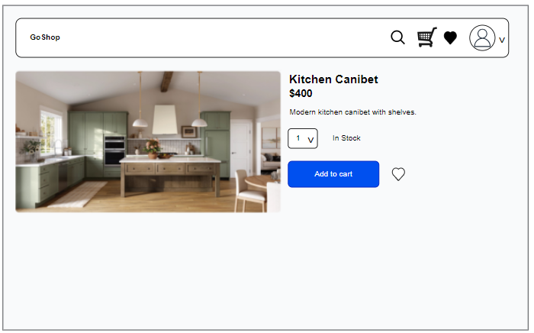
Image 22: Product Detail Interface

The product detail interface aims to display detailed product information to the customer.

Shopping Cart Interface
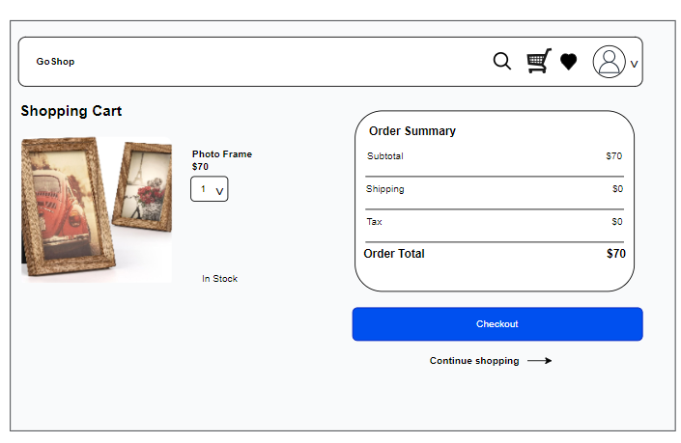
Image 23: Shopping Cart Interface

The shopping cart interface aims to help buyers interact with the cart to enhance the shopping experience.
Checkout Interface
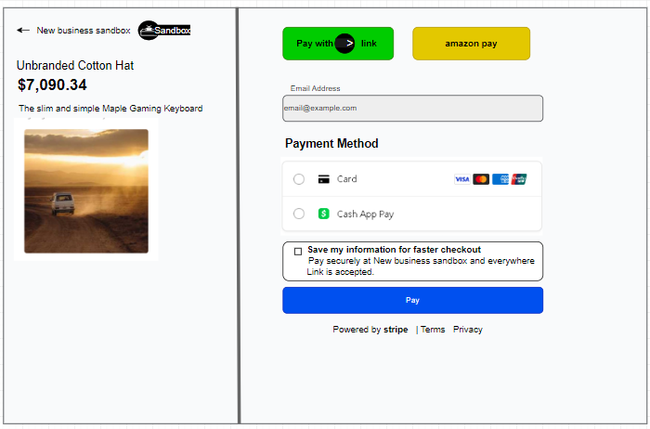
Image 24: Checkout Interface

The checkout interface helps users perform transactions immediately on the website after selecting their desired items.

Account Information Editing Interface
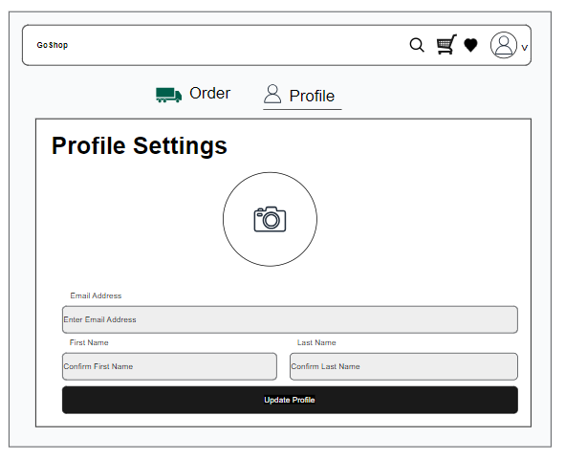
Image 25: Account Information Editing Interface

The account information editing interface aims to help users adjust their account information as desired.
- System Design
  - Block Diagram
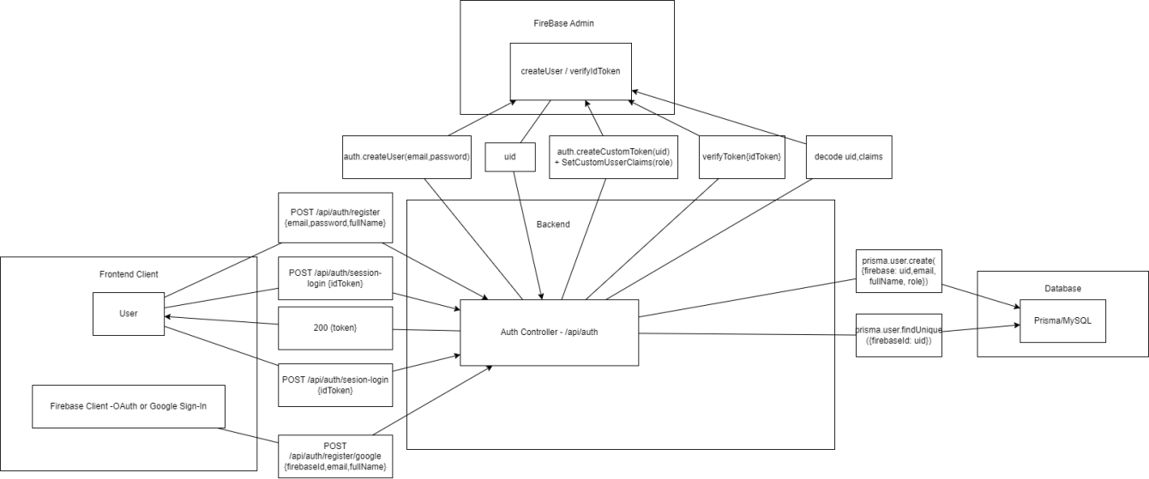
Image 26: Block Diagram

The diagram illustrates the user authentication process within the system, following a model that separates the Frontend, Backend, and Firebase. Users perform registration or login from the Frontend using email-password or Google Sign-In. Firebase Authentication is responsible for verifying identity and issuing an ID Token. This token is sent to the backend, where the Auth Controller uses Firebase Admin to verify, decode the token, and retrieve user information. Subsequently, the backend saves or cross-references user data with the MySQL database via Prisma. This approach ensures authentication security while keeping all business logic and user data centralized at the backend.
  - Decomposition View
    - C1
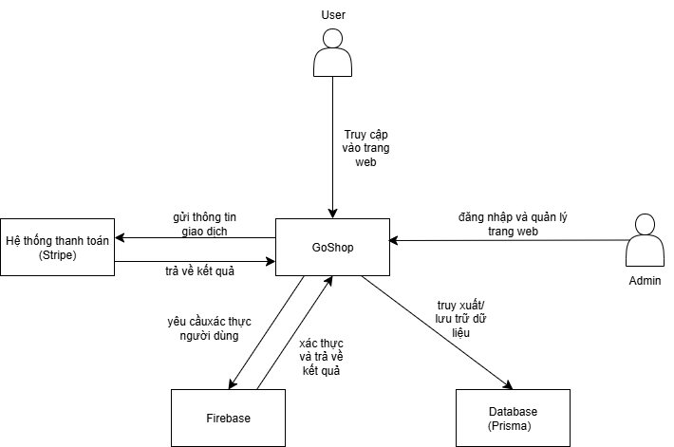
Image 27: C1 diagram
GoShop is the central software system being built, playing the role of processing all business operations of the e-commerce application. Users and Admins are external entities, interacting with the system through accessing, logging in, and managing functions on the website. GoShop integrates with Stripe to process payment transactions, where the system sends transaction information and receives success or failure results. Additionally, Firebase is used as an external service to perform user authentication and return authentication results to the system. GoShop's data is stored and retrieved through the Database, with Prisma acting as the intermediate layer to connect and manipulate the physical database
    - C2
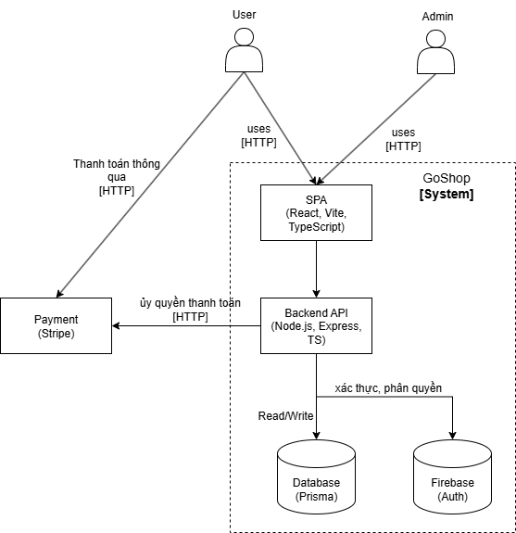
Image 28: C2 diagram
The Level 2 Container diagram describes the high-level architecture of the system by dividing GoShop into independently deployable components. The system includes a Single Page Application (SPA) built with React, Vite, and TypeScript, acting as the user interface for both Users and Admins, receiving interactions and sending requests to the Backend API. The Backend API, developed using Node.js, Express, and TypeScript, is the center for processing business logic, coordinating the payment process, communicating with the database via Prisma, and performing authentication and authorization via Firebase Auth. The Database handles the storage of business data such as products, orders, and user information, while Firebase is responsible for identity management and authentication tokens. Furthermore, the system integrates Stripe to process payments, where the Backend creates and manages transactions, while the user interacts directly with the payment interface provided by Stripe.
    - C3 (module-level)
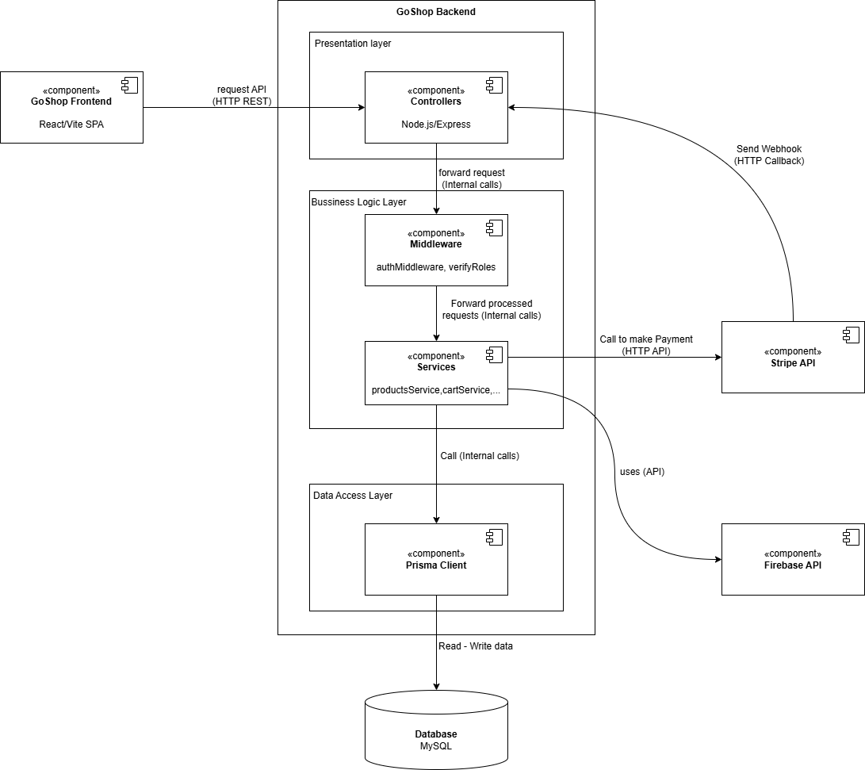
Image 29: C3 (module-level)
The Level 3 Component Diagram of the GoShop Backend describes the internal architecture of the Backend by separating the Backend Container into functional components according to a layered architecture. The Backend is organized into three main layers: Presentation Layer, Business Logic Layer, and Data Access Layer. The Presentation Layer includes Controllers, acting as entry points for APIs, receiving requests from the Frontend and routing them into the system. The Business Logic Layer consists of Middleware and Services, where Middleware handles common functions such as authentication and authorization, while Services execute core business logic and communicate with external systems like Stripe for payments and Firebase for user verification. The Data Access Layer is represented by the Prisma Client, responsible for retrieving and storing data in the MySQL database. Additionally, the Backend receives webhooks from Stripe to update transaction statuses, ensuring data consistency for orders in the system.
    - C4
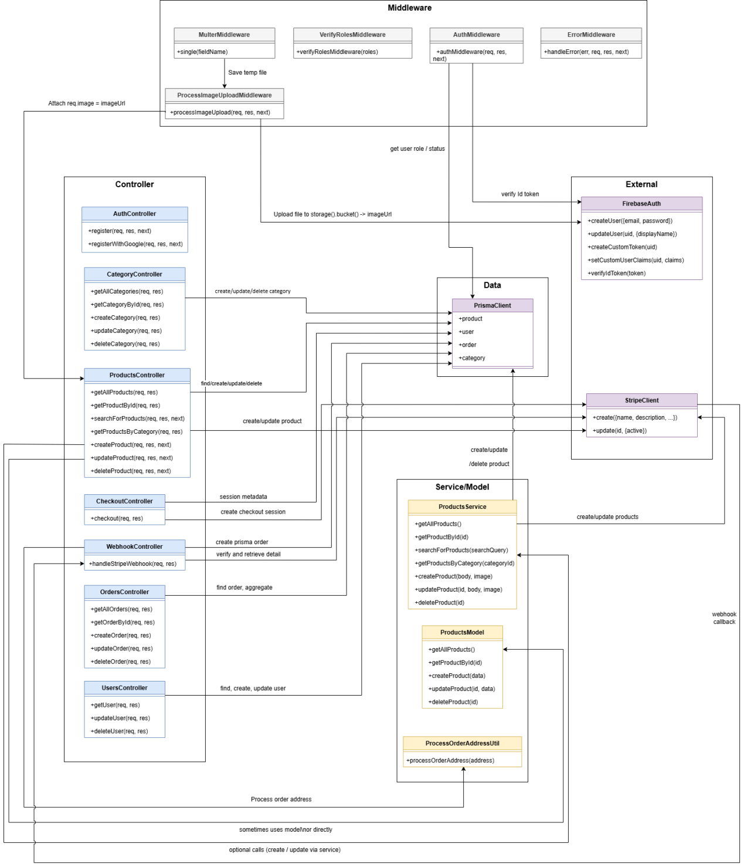
Image 30: C4 diagram

The Level 4 Code Diagram of the GoShop Backend describes the detailed source code structure within the Backend Components and the call relationships between them. The processing flow begins when a request enters the system and is sequentially processed through a chain of Middleware for token authentication, permission checking, data schema validation, image processing, and centralized error management. The request is then transferred to the corresponding Controller based on specific business functions such as authentication, products, categories, orders, payments, or webhooks. Controllers act as coordinators, receiving preliminary processed requests and calling Service Models to execute core business logic. At the Service layer, the system processes complex workflows such as product management, orders, delivery addresses, and payments, while manipulating data via PrismaClient or calling external services like FirebaseAuth and StripeClient. This organization ensures the source code is clear, with separated responsibilities, making it easy to maintain and expand.
  - Communication View
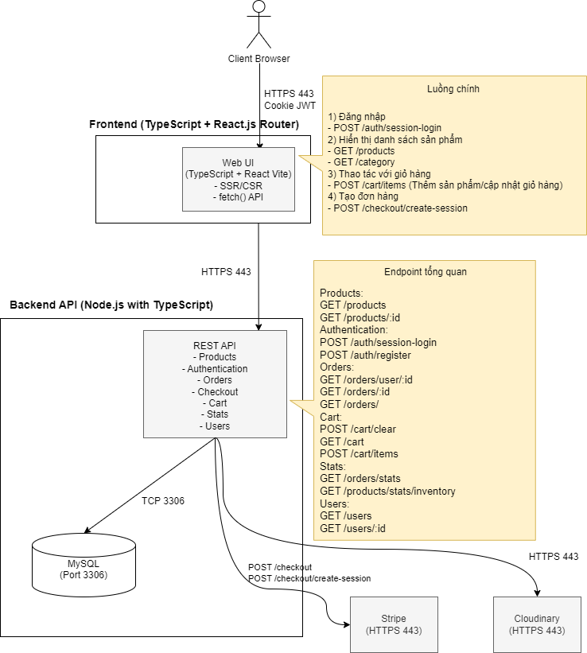
Image 31: Communication View

The system operates on a closed loop starting from the User Layer, where users access via browser using the secure HTTPS protocol (Port 443) to encrypt data. Upon successful login, the system uses JWT Cookies to store authentication codes, helping the browser identify users in subsequent sessions without re-login. Data from the browser is sent to the Interface Layer (Frontend) built on React.js/Next.js and TypeScript platforms; here, the system flexibly combines SSR for SEO optimization and fast page loading with CSR to handle smooth interactions via fetch() API requests sent downstream. Receiving those requests is the Central Processing Layer (Backend API) written in Node.js, operating on REST API architecture with separate functional clusters such as Product Management, Authentication, and Orders/Cart. The Backend acts as the coordinating brain, directly querying the Data Layer and External Services including the MySQL database (Port 3306) via TCP protocol to store core information, while connecting with specialized services like Stripe for secure credit card payments or Cloudinary/Supabase for image storage, returning URL links to the database to optimize system speed.

List of APIs
Table 14: List of APIs
Module | Method | Endpoint | Description
Webhook | POST | /api/webhook | Handles webhooks from the payment system or third-party services.
Products | GET | /products/ | Retrieves a list of all products.
Products | POST | /products/search | Searches for products based on given conditions.
Products | GET | /products/category/:id | Retrieves products by category.
Products | GET | /products/:id | Retrieves detailed product information.
Products | POST | /products/ | Adds a new product.
Products | PATCH | /products/:id | Updates product information.
Products | DELETE | /products/:id | Deletes a product.
Auth | POST | /auth/session-login | Logs in using a session.
Auth | POST | /auth/register/google | Registers an account using Google.
Auth | POST | /auth/register | Registers a standard account.
Users | PATCH | /users/update/:id | Updates user information.
Users | GET | /users/:id | Retrieves user information.
Checkout | POST | /checkout/create-session | Creates a new checkout session.
Checkout | GET | /checkout/session/items/:id | Retrieves items in a checkout session.
Checkout | GET | /checkout/session/:id | Retrieves checkout session information.
Category | GET | /category/ | Retrieves a list of all categories.
Category | GET | /category/:id | Retrieves category information by ID.
Orders | GET | /orders/ | Retrieves all orders.
Orders | GET | /orders/user/:id | Retrieves orders for a specific user.

  - Deloyment View
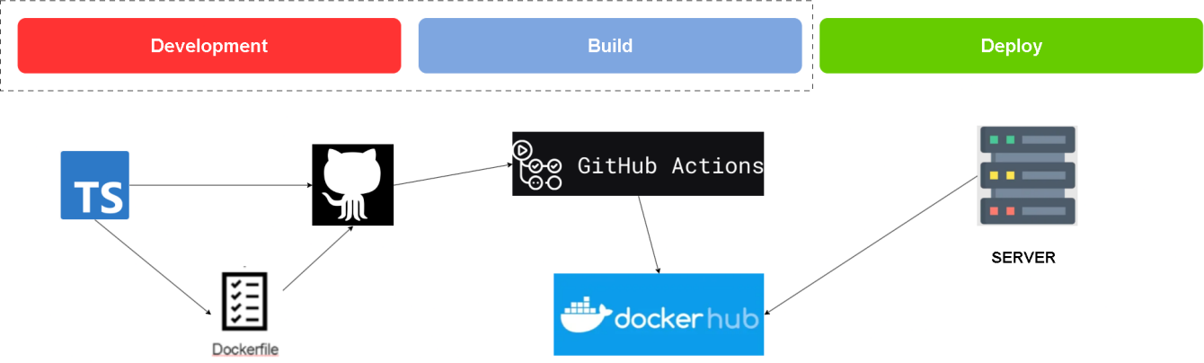
Image 32: Deloyment View

The GoShop website is written in TypeScript; the backend compiles it into JavaScript for use. A Dockerfile and Nginx are created to serve static files for React, and everything is pushed to GitHub. After pushing to GitHub, GitHub Actions is triggered; it automatically builds the Docker image upon code push, then pushes the image to DockerHub. Subsequently, it sets up the server, pulls and runs the image, and automates deployment.

CHAPTER 3: TEST PLAN

Introduction
The GoShop project is a fullstack e-commerce system: the backend is built with TypeScript/Node.js (using Prisma, Express/Koa or similar), and the Frontend for customers and administrators uses Vite + React/TS. The main objective is to provide a platform for product management, shopping carts, payments, and order administration for online stores.

Purpose
Build a stable, scalable, and easy-to-operate online sales platform. Support sales processes: category management, product management, order management, payments, and statistics. Provide an admin interface for administration and quick order processing.

Context
The GoShop project is a Web Application serving e-commerce needs. The system is developed mainly based on TypeScript (76.1%), combined with HTML and JavaScript to build user interfaces and processing logic. The technical characteristics of the project require testing to focus on browser compatibility (due to the use of HTML/JS) and data integrity (due to the specifics of TypeScript) within shopping transaction flows.

Scope
The testing scope of the GoShop project focuses on verifying and ensuring that the main functions of the e-commerce system operate according to business requirements and provide a stable user experience.

Functional
Focus on checking the core business flows of the GoShop e-commerce system to ensure operation according to design requirements.
Account Management (Auth): Registration, Login (Email/Password, Social Login if any), Forgot Password, Change Password, Update Personal Information, Delivery Address Management.
Product Management (Product): Display product list, Search, Filter products (by price, category), View product details.
Shopping Cart (Cart): Add product, Update quantity, Delete product, Calculate provisional total.
Ordering and Payment (Checkout): Enter address, Select payment method, Complete order.
Order Management (Order): View order history, Track order status (Pending, Accepted, Rejected).
Order Statistics (Stats): View profit charts, order ratio pie charts, export charts as Excel.

Compatibility
Since the project uses TypeScript/JavaScript and HTML (Web application), testing is required on various environments.
Browser: Chrome, Firefox, Safari, Edge (latest versions and 1-2 older versions).
Operating System (OS): Windows, macOS, Linux (for server/dev side), iOS, Android (on mobile browsers).
Device: Laptop/Desktop (different screen resolutions), Tablet, Mobile (Responsive Design).

User Interface (UI)
Check details of user interface components based on Frontend source code (HTML/CSS/TS).
Responsive: Check display on breakpoints (Mobile, Tablet, Desktop). Ensure layout is not broken and content does not overlap.
Form Elements: Check the display and operation of textboxes, checkboxes, radio buttons, dropdown lists, buttons (active/disabled states).
Images & Media: Ensure product images load correctly, are not distorted, and display placeholders when image loading fails.

Security
Authentication & Authorization: Check access permissions (Regular users cannot access Admin pages). Check session timeout and safe logout.
Input Validation: Check protection against common errors like SQL Injection (if using SQL) or NoSQL Injection (if using MongoDB), XSS (Cross-site Scripting) in search and comment boxes.
Data Protection: Ensure passwords are encrypted (hashing) in the DB, and sensitive information is not displayed in the URL or Console log.

Database
Check data integrity and accuracy (based on models defined in TypeScript/Backend code).
Data Integrity: Data saved to the DB must match data entered from the Frontend (Example: Amount, inventory quantity).
Data Constraints: Check constraints (Not Null, Unique Key for Email/Username, Foreign Key between Order and User).
CRUD Operations: Ensure Add, Edit, and Delete operations correctly update the status in the database.
    - Performance
Evaluate the load-bearing capacity of the GoShop system, especially the Backend (API).
Load Testing: Check loading speed of the home page and product detail page when 10, 50, 100 users access simultaneously.
Response Time: Measure response time of critical APIs (Search, Add to Cart, Checkout). Target < 2 seconds.
Stress Testing: Find the system's breaking point when traffic increases suddenly (e.g., simulating sales days).

Crowd Testing
Open the project for real users to participate in testing.
Beta Testing: Invite a limited group of users to experience the product to gather feedback on actual experience and strange bugs that the internal team has not detected.

API
Endpoint Validations: Check that all endpoints (GET, POST, PUT, DELETE) return the correct Status Code (200, 201, 400, 401, 404, 500).
Payload Verification: Check if the JSON request and response structure matches the document format.
Business Logic via API: Check calculation logic (price, inventory) directly via API without going through the interface.
Error Handling: Send requests missing mandatory fields or with incorrect formats to check the Backend's error response.

Risk List

Table 15: Risk List
No. | Potential Risk | Impact Level | Mitigation Measure
1 | Environment testing not set up correctly | High | Check configuration carefully before each build.
2 | Data used for testing is missing or incomplete | Medium | Prepare and review the mock data set more thoroughly.
3 | Stripe payment gateway integration error | High | Re-check the configuration and sandbox of the payment gateway.
4 | Search or Filter modules operate slowly | Medium | Use a test dataset of sufficient size to optimize performance.
5 | Interface display discrepancies between browsers/devices | High | Perform compatibility testing (Cross-browser/device testing) on multiple environments.

Items to be Tested

Functional
Focus on checking the core business flows of the GoShop e-commerce system to ensure operation according to design requirements.
Account Management (Auth): Registration, Login (Email/Password, Social Login if applicable), Forgot Password, Change Password, Update Personal Information, Manage Delivery Address.
Product Management (Product): Display product list, Search, Filter products (by price, category, brand), View product details, Related/Suggested products.
Shopping Cart (Cart): Add product, Update quantity, Remove product, Calculate provisional total.
Ordering and Payment (Checkout): Select address, Select shipping method, Select payment method, Apply discount code, Complete order.
Order Management (Order): View order history, Track order status (Pending, Shipping, Delivered, Cancelled).
Admin Dashboard: User management, Product CRUD, Category management, Order processing.

Usability
Evaluate user experience on the web interface (HTML/CSS/JS) to ensure ease of use and friendliness.
Navigation: Check the logic of menus, breadcrumbs, and page transition links. Verify if users can easily find products.
System Notifications: Check the clarity of error messages (form validation), success messages (add to cart, order placement), and instructional tooltips.
Operational Experience: Evaluate the number of steps required to complete a purchase (optimize checkout flow).
Aesthetics: Check if the layout, fonts, and colors are consistent and easy to view.

Performance
Evaluate the load-bearing capacity of the GoShop system, especially the Backend (API).
Load Testing: Check the loading speed of the home page and product detail page when there are 10, 50, 100 concurrent users accessing.
Response Time: Measure the response time of critical APIs (Search, Add to Cart, Checkout) with a goal of < 2 seconds.
Stress Testing: Find the limit point of the system when traffic increases suddenly (e.g., simulating a sale day).
  - Compatibility
Since the project uses TypeScript/JavaScript and HTML (Web application), testing is required on various environments.
Browser: Chrome, Firefox, Safari, Edge (latest versions and 1-2 older versions).
Operating System (OS): Windows, macOS, Linux (for server/dev side), iOS, Android (on mobile browsers).
Device: Laptop/Desktop (different screen resolutions), Tablet, Mobile (Responsive Design).

Items Not to be Tested

3.1. Third-party System Functions
The group does not perform testing on the internal processing functions of the third-party payment gateway. Only the stability and performance when connecting to the payment gateway are ensured.

3.2. Advanced Security Testing
Penetration Testing and in-depth security tests are not performed. The group only performs basic security testing, focusing on access control and user authorization.

3.3. In-depth Usability Testing
User Acceptance Survey: Real-world experience sessions with sample user groups (Beta testers) are not organized in this phase (unless there is a separate UAT request).
Accessibility Compliance: Strict compliance with WCAG (Web Content Accessibility Guidelines) standards for people with disabilities is not tested, except for basic requirements regarding contrast and keyboard navigation.

4. Acceptance Test Criteria

4.1. Test Coverage
Test Acceptance Criteria – GoShop:
◦ Test coverage ≥ 95% of functions.
◦ Page loading performance ≤ 5 seconds.
◦ Passwords encrypted, no user data leakage.
◦ Team leader confirmation required before moving to UAT.

4.2. Test Case Pass Rate
Test case pass rate ≥ 90%.
Limit Critical/High severity defects.

4.3. Number of Test Cases
All test cases at the following levels must be executed 100%:
Unit Test.
Integration Test.
System Test.

4.4. Unit Test Density
Testing density must reach a minimum of 30 Unit Test Cases per 500 lines of source code for business logic processing modules (Backend Services, Utility Functions)

4.5. Source Code Coverage
To ensure source code quality and minimize potential errors in processing logic, the group has established thresholds for source code coverage as part of the Acceptance Criteria. These parameters are measured via automated testing tools (such as Jest, JaCoCo, or Istanbul) during the execution of Unit Tests.

4.6. Number of Defects
Critical Defects: Maximum 4 errors. The system is not allowed to have multiple errors causing crashes, data loss, or blocking the payment flow at the time of handover.
Major Defects: Maximum 08 errors. These errors must have a temporary workaround approved by the Product Owner and a plan for fixing (Hotfix) immediately after release.
Minor/Cosmetic Defects: A small number is allowed to exist but must not affect the main user experience and must be recorded in the backlog for processing in the next Sprint.
1. Statement Coverage ≥ 70%
◦ Definition: Measures the percentage of statements in the source code executed at least once by the test suite.
◦ Significance: With a 70% threshold, the group ensures that the majority of processing logic, assignment statements, and function calls have been checked. This index helps confirm that there is no "dead code" or ignored critical logic blocks in the core modules of GoShop.
2. Branch Coverage ≥ 50%
◦ Definition: Measures the percentage of decision branches (such as if-else, switch-case structures) checked across both True and False states.
◦ Significance: The 50% threshold focuses on controlling logical branching flows. Although lower than Statement Coverage due to the complexity of logic combinations, this figure ensures that exception paths and critical branching business flows (e.g., what to do if payment fails, how to notify if out of stock) have been significantly covered.
3. Function Coverage ≥ 70%
◦ Definition: Measures the percentage of functions or methods in the entire project called and executed by the test suite.
◦ Significance: With 70%, the group affirms that nearly all business features packaged in functions (such as total calculation, JWT validation, cart processing) have been directly tested. This is the most important index to prove the integrity of services in the system.

Benefits of Coverage Thresholds:
◦ Quantify Quality: Instead of saying "tested thoroughly", the numbers 70%, 50%, and 70% provide concrete evidence to the thesis council regarding the maturity of the source code.
◦ Automate QA Process: These parameters are integrated into the CI/CD process. If new source code does not meet these thresholds, the system will warn, forcing developers to add Unit Tests.
◦ Minimize Technical Debt: Maintaining high coverage makes future upgrades and maintenance of the GoShop system safer, avoiding regression bugs.

4.7. CI/CD Process
All workflows established on GitHub Actions, including steps from packaging source code, Linting checks, to building the GoShop project, must be fully executed and reach "Success" status (marked with a green check).
This process is considered failed if any "Job" or "Step" in the CI/CD flow is interrupted, encounters a system error, or ends with a "Failed" status. Achieving complete success is a prerequisite to ensure new source code does not break the current structure and is ready for subsequent deployment stages.
Failure Criteria: During Pipeline execution, the system automatically launches the entire test suite (including Unit Test and Integration Test). The mandatory acceptance criterion is a 100% pass rate, meaning no test scenario is allowed to fail.
Any test error arising in the automated Pipeline, no matter how small, will directly block the "Merge" process of source code into the main branch. This ensures absolute stability of the GoShop system, prevents regression bugs, and maintains software quality at the highest level before integration.

5. Test Strategy

5.1. Test Methodology
To ensure strictness and quality throughout the software lifecycle, the project adheres to the V-Model. Here, the testing process is conducted in parallel and symmetrically with the development stages. The system is controlled through 4 levels: Unit Test, Integration Test, System Test, and Acceptance Test, with Test Cases built closely following functional requirements and Use Cases. Additionally, the CI/CD process is established using GitHub Actions to automate the entire Build, Test, and Deploy chain, enhancing work efficiency.

5.2. Types of Testing
Table 16: Types of Testing
Activity | Role/Description
Functional Testing | Performed to meet the agreed functional requirements of the GoShop website application. The following functions will be tested:  - Registration  - Login  - Cart  - Payment  - Product Catalog  - Favorite Products  - Product Management  - Check All Orders  - User Account Management.  All tested features will be described in detail in the Test Scenario and Test Case documents.
Data Testing | Performed to define the database containing GoShop website management information, run queries, and meet user data storage requirements.
Security Testing | Performed to meet the agreed security requirements of the GoShop Website.
UI Testing | Performed to ensure the user interface is designed correctly, is visually appealing, easy to use, and provides a good user experience.
Performance Testing | Performed to measure system performance - speed, load capability, and data volume.
Compatibility Testing | Performed to check if the website is compatible with browser configurations:  - Google Chrome  - Mozilla Firefox  - Opera  - Microsoft Edge  - Brave.
Crowd Testing | Performed to detect bugs, compatibility issues, and real user experience through other tester groups.
API Testing | Performed to check the accuracy and stability of APIs regarding returned data, status codes, and the validity of requests and responses.

5.3. Testing Level

Table 17: Testing Level
Type of Testing | Purpose | Technique | Method
Unit Testing | Check the correctness of functions/methods | White Box | Automated testing using JUnit and Mockito in Development/CI environment.
Integration Testing | Check interaction between functional modules | Black Box | Automated testing using Spring Boot Test, MockMvc, and H2 in Development/CI environment.
System Testing | Check business flows and interfaces | Black Box | Automated testing using Selenium (UI, E2E) and K6 (performance) in Development environment.
Acceptance Testing | Check and accept the product | Black Box | Manual testing in Production environment.

Table 18: Testing Matrix
Type of Tests | Stage of Test
Type of Tests | Unit | Integration | System | Acceptance
Function Test | X | X | X | X
User Interface test | X |  | X
Performance Tests  (Performance profiles of individual components) | X | X
Load, Stress, Volume test |  |  | X | X
Security test | X |  | X
Database test |  | X | X
Adhoc test |  | X | X

6. Test Execution Plan

Human Resources

Table 19: Human Resources
Performer | Role | Main Responsibilities
Vo Van Luan | Tester/Developer | Plan testing, allocate resources, control progress and output quality.
Do Tan Loc | Tester/Developer | Design Test Cases, perform Frontend testing (Auth, Cart, Admin), log bugs, and verify bugs.
Nguyen Huu Anh Khoa | Tester/Developer | Write Unit Tests, configure CI/CD pipeline on GitHub Actions, responsible for reviewing CI/CD Test results.
Le Duy Tin | Tester/Developer | Support requirement clarification, perform UAT to accept the product.

7. Test Environment

7.1. Hardware

Table 20: Hardware
Item | Component | Purpose
Development | Personal Computer | Programming, running Unit Tests and Integration Tests.
Devices | Desktop, Android, iOS | UI Testing and Compatibility Testing.

7.2. Software

Table 21: Software
Item | Component | Purpose
Development | VSCode, ReactJS, Local MySQL | Programming, running Unit Tests and Integration Tests.
Browsers | Chrome, Firefox | UI Testing and Compatibility Testing.

7.3. Infrastructure
Table 22: Infrastructure
Item | Component | Purpose
Production | MySQL, Frontend and Backend deployed on Railway | Actual software deployment, performing System and Acceptance Testing.
CI/CD | GitHub Actions | Automating Build, Test, and Deploy processes.

8. Deliverables

Table 23: Deliverables
Item Type | Format | Content Details
Project Documents | Word (.docx) | Architecture Design & Database Design  Test Plan & Bug Report  Project Summary Report.
Testing & Detailed Documents | Excel (.xlsx) | Interface List & Use Case Specification  Review Checklists  Test Design, Test Case, Test Report
Source Code & Automation | GitHub | Source Code  Test Scripts (Unit, Integration, System)  CI/CD Pipeline (.github/workflows/ci.yml, CD on Railway).

CHAPTER 4: TESTING METHODS

1. Introduction
This chapter presents the process and results of designing detailed test cases based on the V-Model strategy.

2. V-Model Test Design Process
The project's testing process is built on the V-Model structure, a methodology emphasizing symmetry and the close relationship between development stages and corresponding testing levels. Instead of testing occurring only at the final stage, the V-Model allows the team to perform test preparation activities in parallel with analysis and design, optimizing early error detection.
Specifically, the synergy in the process is demonstrated through the following corresponding levels:
Requirement Gathering & Acceptance Testing: The initial phase focuses on identifying customer needs. This is the sole basis for building the User Acceptance Test (UAT) suite to confirm whether the software meets business goals and user acceptance criteria.
Requirement Analysis & System Testing: Detailed business requirements are transformed into End-to-End system test scenarios. This stage ensures the software operates stably in a real environment, including the user interface (UI) and performance.
System Design & Integration Testing: The architectural structure and interaction between modules are verified through integration tests, confirming the accuracy of data flow between API, Backend, and Database.
Detailed Design & Unit Testing: Internal processing logic within each function is directly verified by unit tests, ensuring every branch logic (Branch Coverage) operates correctly according to technical specifications.
Applying the V-Model not only helps the team maintain Traceability—where every requirement has at least one corresponding test case—but also ensures system quality is strictly controlled from the smallest units of source code to entire complex business flows.

2.1.Requirements & Acceptance
In the initial stage, the team focused on clarifying the actual business flows of the online physical book selling system. Priority was given to identifying user behaviors and necessary business rules for smooth system operation.
Through Workflow Analysis, the team defined the system based on the interaction of two main actors:
Customer: Focuses on the experience of searching, selecting products, managing the shopping cart, and completing the payment process safely.
Administrator (Admin): Focuses on the ability to control order data, manage categories, user accounts, and extract profit statistical reports.
The system is decomposed into 07 core functional modules: Authentication, Product Category, Shopping Cart, Order Management, Order Statistics, Account Management, and Payment Process. All these requirements are directly converted into Acceptance Criteria , which serve as the practical basis for verification at the final stage of the process (Acceptance Testing).

2.2. System Analysis and System Testing Planning
Upon the formalization of acceptance criteria, the team embarked on the System Analysis phase. This represents a vital transition from grasping user needs to specifying the system’s overarching operational logic. The focus was placed on modeling comprehensive End-to-End workflows and the interaction architecture of various components.
Core analysis content includes:
- Business Flow Analysis: The team uses Activity Diagrams to detail complex business routes. This analysis helps identify decision points and exception scenarios.
- Use Case Analysis: Clarifies the relationship between actors (Customer, Admin) and the services provided.
The deliverables from the System Analysis phase serve as the definitive and direct foundation for constructing the System Testing suite. Furthermore, to maximize testing efficiency, the team implemented an Automation Testing framework leveraging Selenium WebDriver:
- User Simulation: Analyzed business flows are converted into Selenium code to simulate real customer behavior (clicks, input, navigation)
- End-state Verification: Based on system requirements, the team established specific Assertions (verification points). Selenium validates the consistency between actual UI elements and the predefined expected states identified during the analytical phase.
- Automated Regression Testing: Systematic analysis enables the construction of resilient Selenium scripts. These scripts facilitate rapid re-validation of the entire system's functionality upon source code changes, eliminating the need for exhaustive manual intervention.
The synergy between detailed system analysis and Selenium automation ensures that the software not only functions correctly from a technical standpoint but also delivers a seamless user experience in a production-like environment.

2.3. Architectural Design and Integration Testing
The architectural design phase is pivotal in defining the system's framework. The team utilized the C4 Model (Context, Container, Component, Code) to systematically decompose the system, moving from a high-level contextual overview to granular technical components. The primary objective was to establish a clear Separation of Concerns (SoC), layered structures, and robust Interfaces for inter-component communication.
Designs at the Container level (Backend, Frontend, Database) and Component level serve as the primary blueprint for Integration Testing. This stage focuses on verifying the integrity of data flows across the established Integration Points within the architecture.
To achieve efficient automated integration testing, the team implemented API-level testing using Jest in conjunction with Supertest. This allows for simulating HTTP requests and verifying the complete execution flow (Controller → Service → Repository) without deploying a live server.
Regarding data management, the team utilized Prisma with mocked or dedicated test databases configured in jest.setup.js. Tests perform data seeding before execution and cleanup (e.g., prisma.user.deleteMany) within lifecycle hooks (beforeEach/afterEach) to ensure isolation and prevent side effects. External SDKs and peripherals (Stripe, Firebase, Cloudinary, etc.) are mocked to maintain test stability and execution speed.
Integration Testing Examples:
Name | Objective | Input | Expected Result | Explanation
updateUser | Test the API flow when the account owner updates their profile — the endpoint returns updated user information and a token. | Có user test trong DB:firebaseId = 'acc-user-1'  email='acc@example.com'  fullName = 'Old Name'  role = 'USER', status = 'ACTIVE'  . | HTTP 200; the response contains the user with the fullName changed to 'New Name'; the response contains a token. | This is an API-level integration test (equivalent to the MockMvc flow). A mock authentication middleware provides the UID, and the request flows through the Controller → Service → (calling Firebase mock) → Repository (Prisma) and returns the payload. Data seeding and cleanup ensure test isolation.
lockUser | Ensure locked users (status: HIDDEN) cannot access protected endpoints. (example /cart). | create user test:  firebaseId = 'lock-user', email = 'lock@example.com', fullName = 'Lock', role = 'USER'. | Request to /cart returns HTTP 401 or 403. | This test verifies the access policy based on user status: when the status is set to HIDDEN, the middleware or controller must block access to protected routes. The test model uses direct seeding or updating via Prisma to bring the application to the desired state, then sends an actual request to verify the entire flow.
Table 24: Examples of Integration Testing

2.4. Detailed Design and Unit Testing
Detailed design (Module Design) represents the lowest level of the V-Model's left branch. The team focused on defining the internal structure of each software component. Class Diagrams were the primary tool used to detail attributes, methods, data types, and relationships (Dependency, Association, Inheritance) between objects.
The Synergy between Detailed Design and Unit Testing:
Detailed architectural specifications serve as the direct basis for Unit Testing suites. This White-box testing process focuses on verifying the correctness of the smallest source code units before they are integrated into larger subsystems.
Unit Testing Strategy:
Tooling: Utilized Jest (ts-jest) with jest.mock() and jest.fn() to isolate dependencies.
Logic Isolation: External dependencies (Prisma, Firebase, Stripe, etc.) are mocked to isolate component logic. Database-dependent scenarios are delegated to integration tests.
Targeted Coverage: Tests are designed to cover critical logic branches (if/else), error handling (try/catch), and edge cases. Istanbul (built-in to Jest) is used to measure Statement, Branch, Function, and Line coverage, prioritizing business-critical flows over arbitrary percentage targets.
A structured unit testing approach based on detailed design serves as a safety net for the codebase. It facilitates seamless code refactoring and updates by guaranteeing that core functionalities are preserved throughout the development lifecycle.

Name | Description | Input | Expected Result
UT-CART-001 | Return 401 if uid is missing from the request. | req = {} | HTTP 401 Unauthorized
UT-CAT-006 | Successfully create a new category. | body = { name: 'NewCat' }, mock prisma.category.create => { id:3, name:'NewCat' } | HTTP 201
Table 25: Unit Testing Strategy

3. Test Design Techniques

3.1. Black-Box Testing
Equivalence Partitioning:
In the test case suite for the Authentication and Account Management modules, input data is divided into valid and invalid classes to optimize the number of test scenarios while still ensuring comprehensive coverage.
For Login Functionality:
Valid Class: Correct email and password, with an active account.
Invalid Class: Incorrect password, unregistered email, or a locked account.
For Registration / Information Update Functionality:
Valid Class: New email that does not yet exist, and phone numbers in the correct format (10-11 digits).
Invalid Class: Email already exists in the system, phone numbers containing special characters or letters, or mandatory fields left blank.
=> Test Case Evidence:
AUT-001, AUT-009: Valid Login/Registration.
AUT-002, AUT-003, AUT-010, AUT-011: Invalid Login/Registration (wrong password, duplicate email).
ACC-008, ACC-009: Updating phone numbers with invalid characters.
State Transition Testing
The team applies this technique to verify the correctness of objects with complex lifecycles. The goal is to ensure that actions can only be performed when the object is in the permitted state, and that state transitions occur consistently following each event.
- User Account Status Management
The status of an account determines the access rights to the system. Scenarios are designed to verify changes in permissions when an Administrator performs lock or unlock operations.
States: Active, Locked.
Transition Events: Administrator executes a Lock or Unlock command.

Test Case ID | Starting State | Event (Action) | Destination State | Expected Result
ACC-002 | Active | Admin locks account | Locked | User login returns "Account is locked" error.
ACC-004 | Locked | Admin unlocks account | Active | User can login again normally.
ACC-003 | Active (Logged in) | Admin locks account | Locked (Log out) | User is immediately redirected to the Login page.
Table 26: User Account State Management

B. Order Workflow Management
The lifecycle of an order passes through multiple stages. This technique ensures that orders do not skip states (e.g., jumping from Pending directly to Delivered without going through Shipping).
States: Pending, Shipping, Delivered, Cancelled.
Event: Administrator updates the order status.

Test Case ID | Starting State | Event | Destination State | Verification (Assertion)
ODM-003 | Pending | Admin updates status | Accepted/Rejected | User checks "Orders" section and sees the updated status.
CKT-004 | Pending (Checkout) | Admin deletes product/Out of stock | Failure | System does not allow successful order creation.
Table 27: Order Status Management (Order Workflow)

C. Cart State Management
The state of the shopping cart depends on real-time data fluctuations from the admin system.
States: Empty, Populated, Updated, Removed.

Test Case ID | Starting State | Admin Event | Destination State | Actual Result
CART-005 | Populated (Old price) | Admin changes product price | Updated (New price) | Total cart value automatically updates when User refreshes
CART-006 | Populated | Admin removes product from stock | Removed | Product automatically disappears from the User's cart.
Table 28: Shopping Cart Status Management (Cart State)

Bảng quyết định (Decision Table Testing)

This technique is applied to test complex combinations of conditions in Product Filtering (Product Category) and User Authorization (Authentication & Account Management).
Step 1: Identify the Conditions
Based on the requirements of the product filtering module, the team identified 3 main conditions that affect the display results:
C1: The user enters a search keyword.
C2: The user selects a product category.
C3: The user selects a "sort by price" criterion.
Step 2: Identify the Actions
Corresponding to the combinations of conditions, the system will perform the following actions:
A1: Display the product list by name (Search result).
A2: Filter the product list by category (Filtered result).
A3: Re-sort the display order (Sorted result).
Step 3: Calculate the number of Rules 9
Each condition (C1, C2, C3) has 2 values: Yes or No.
The number of calculated rules is 2 * 2 * 2 = 8 (Rules)
Step 4: Full Decision Table
Condition/Rule | R1 | R2 | R3 | R4 | R5 | R6 | R7 | R8
C1: Has keyword | N | N | N | N | Y | Y | Y | Y
C2: Has category | N | N | Y | Y | N | N | Y | Y
C3: Has sorting | N | Y | N | Y | N | Y | N | Y
Action
A1: Display by name |  |  |  |  | X | X | X | X
A2: Filter by category |  |  | X | X |  |  | X | X
A3: Sort by price |  | X |  | X |  | X |  | X
Table 29: Full Decision Table

Step 5: Reduced Decision Table (Focusing on Integration Cases)
The team focused on reducing the table to handle the most important integration scenarios (integration logic), where techniques such as single Equivalence Partitioning do not provide full coverage:
Reduced Rule | Scenario Description | Expected Result | Test Case ID
Combination Rule 1 (R7) | Search + Select Category | Display products containing the keyword and belonging to the correctly selected category. | CAT-007
Combination Rule 2 (R6) | Search + Sort by Price | Display products by name and sorted by the requested price order. | CAT-008
Combination Rule 3 (R8)) | Search + Category + Sort | Results must simultaneously satisfy all 3 filters: Name, Category, and Price order. | CAT-009
Table 30: Reduced Decision Table
Boundary Value Analysis (BVA)
This technique is used to check "sensitive points" where data transitions between valid and invalid states.

A. Data Length (Authentication & Account Management Module)
Password (AUT-014): Regulated at a minimum of 6 characters.
Boundaries: 5 characters (Error), 6 characters (Valid).
Phone Number (ACC-010, ACC-011): Regulated from 10 - 11 digits.
Lower Boundary: 9 digits (Error), 10 digits (Valid).
Upper Boundary: 11 digits (Valid), 12 digits (Error).

B. Quantity and Inventory (Cart & Order Module)
Quantity added to cart (CART-002):
Assuming inventory = 10.
Boundaries: Adding 10 products (Success), adding 11 products (Error: Insufficient stock).
Order ID Search (ODM-005): Testing with the minimum ID (1) or non-existent IDs (negative numbers/0).

3.2. While-box Testing
White-box testing is performed by the team to verify the internal structure and detailed processing logic of the source code. Instead of focusing only on inputs and outputs, this method allows for control over the entire control flow and data flow within the system.
To evaluate the effectiveness of this process, the team applies three core coverage criteria as measurements:
.1.Statement Coverage: This is the most basic criterion, measuring the percentage of executable statements in the source code that have been run by the test suite. The team's goal is to ensure there is no "dead code" and that every important line of code is executed at least once to avoid potential syntax or logic errors.
2.Decision/Branch Coverage: This criterion focuses on decision points in the code (such as if-else, switch-case, while). The team designs scenarios to ensure every branch of the control flow is executed (both True and False cases). This is critical for ensuring the system reacts correctly under all business branching conditions.
3.Condition Coverage: Going deeper into complex logical expressions, this criterion requires each individual condition within a logical expression (e.g., AND, OR operators in an if statement) to be tested with both True and False values. This helps eliminate errors when combining multiple logical conditions
Actual Coverage Results (Coverage Report)
The team used the integrated Jest tool to collect the following actual metrics:

Component (File/Folder) | % Statement | % Branch | % Function | % Line | Evaluation
Total (All files) | 79.18 | 54.21 | 85.29 | 79.74 | Fair
config/stripe.ts | 100 | 100 | 100 | 100 | Absolute
controllers/auth.ts | 87.5 | 66.66 | 100 | 86.11 | Good
controllers/cart.ts | 83.51 | 79.16 | 100 | 82.08 | Good
controllers/category.ts | 95.74 | 72.72 | 100 | 94.59 | Very Good
controllers/checkout.ts | 79.16 | 38.00 | 100 | 79.48 | Average
controllers/orders.ts | 69.93 | 58.73 | 73.33 | 72.32 | Needs Improvement
controllers/products.ts | 87.59 | 68.22 | 90.47 | 87.25 | Good
controllers/users.ts | 76.14 | 63.79 | 85.71 | 74.46 | Fair
controllers/webhook.ts | 66.00 | 27.39 | 66.66 | 65.11 | Low
services/productsService.ts | 92.00 | 76.00 | 85.71 | 95.45 | Very Good
utils/dbMetrics.ts | 69.38 | 42.42 | 71.42 | 81.57 | Average
utils/metrics.ts | 86.95 | 12.50 | 0.00 | 86.95 | Notable
utils/processOrderAddress.ts | 28.57 | 0.00 | 0.00 | 16.66 | Very Low

Based on the Jest metrics above, the team has provided the following professional evaluations:

A. Strengths

High Function Coverage: Reached 85.29%, indicating that most primary business functions were called and executed during testing.

Stable Controller & Service Layers: Critical files such as auth.ts, cart.ts, and productsService.ts all achieved Statement Coverage above 80%.

Core Logic Verification: This ensures that core business logic has been thoroughly verified.

Secure Configuration: The stripe.ts file reached 100%, ensuring no errors in the payment connection settings.

B. Weaknesses
Low Branch Coverage: Only reached 54.21%.
Untested Logic Paths: This indicates that if-else statements, switch-case blocks, or error-handling branches (try-catch) have not been fully tested.
Critical Branch Gaps: Specifically noted in webhook.ts (27%) and checkout.ts (38%).
Webhook & Utils Modules: Files webhook.ts and processOrderAddress.ts show very low metrics.
High-Risk Logic: This poses a significant risk because Webhooks receive data from third parties (Stripe); failure to test error branches could lead to system crashes when data is invalid.
Dead Code: The metrics.ts file has 0% Function Coverage despite high Statement coverage, suggesting code that is declared but never invoked.

4. Manual and Automation Testing

4.1. Manual Testing
During the acceptance testing phase, the team implemented manual testing as a final validation step to evaluate the system from the end-user's perspective. Unlike automated tests that focus on the correctness of the source code, manual testing focuses on real-world experience, complex business flows, and sensory factors that machines cannot replace.
Process and Execution Methods:
Test Scenario Construction: The team designs test suites based on actual business workflows rather than discrete features. This ensures that the system operates smoothly from the user's initial access until the completion of the payment and order receipt process..
Checklist-based Testing: Manual testing is conducted based on the designed Test Cases and Review Checklists. Test results are recorded and compared against expected outcomes before proceeding with system acceptance.

4.2. Automation Testing
The project implements automation testing by integrating a CI/CD process on the GitHub Actions platform. This solution optimizes the software development lifecycle by fully automating stages from building and testing to system deployment.
Operational Mechanism: Whenever new source code is pushed to the GitHub repository or via a Pull Request, the CI/CD pipeline is automatically triggered.The team's project establishes branch protection rules, prohibiting direct pushes to the main branch. Instead, code must be submitted through another branch and merged via a pull request only after all status checks have passed. The system proceeds to set up the environment, build the project, and execute the entire suite of established test scenarios. This ensures that every source code change is verified immediately, helping to detect conflicts early and maintaining continuous system stability.

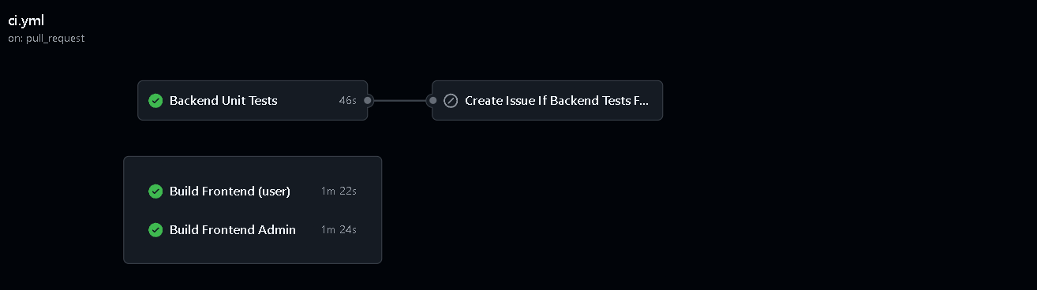
Image 33: GitHub Actions CI Pipeline
If the "Backend Unit Tests" job fails, the pipeline automatically creates a GitHub Issue to log the occurring error, supporting the development team in tracking and resolving it promptly.

CHAPTER 5: REPORTING AND CONCLUSION

- Testing Overview
Upon completing the detailed test design phase in Chapter 4, the team proceeded to execute the testing for the GoShop system in accordance with the established roadmap and plan. The testing process was implemented with strict adherence to the V-Model, spanning from lower to higher levels to ensure software integrity.

The testing phases performed include:
Unit Testing: Verifying the correctness of individual functions and methods handling internal logic.
Integration Testing: Ensuring seamless interaction between modules and third-party services (such as Stripe Payment).
System Testing: Evaluating the overall functionality and performance of the system in a real-world environment.
Acceptance Testing: Validating the system's compliance with business requirements from the end-user perspective.

Throughout this process, the team maintained a maximum focus on core business flows, such as cart management, checkout processes, and administrative features. Every Test Case was executed with meticulous detail; all emerging Defects were categorized, fully documented, and cross-referenced against expected results in the hand-over records. This serves as a critical foundation for the team to assess software quality prior to final acceptance and official deployment.

2. Test Case Report
The test cases are categorized into two groups: Pass (verifying behaviors that align with system expectations) and Fail (handling exceptions and invalid conditions).
The test suite is constructed for the 7 primary functional modules of the system.

Table 31: primary functional modules
No. | Module Name | Module Code | Description
1 | User Authentication | AUT | Verifies the Login (Standard & Google), Sign-up, and Logout processes. Ensures account data integrity and security.
2 | Product Categories | CAT | Tests list display, keyword search, and smart filters (by category, price ascending/descending).
3 | Cart Management | CART | Verifies adding/editing/removing items, total price calculation, and real-time inventory synchronization.
4 | Order Management | ODM | Tests the order list view for Users and administrative controls for Admins (order search, filtering by status/date).
5 | Checkout Process | CKT | Verifies Stripe Payment gateway integration, test card validation, and inventory deduction flow after successful transactions.
6 | Account Management | ACC | Tests Profile updates and advanced administrative permissions such as Locking/Unlocking users or Role modification.
7 | Order Statistics | STAT | Verifies the system's data aggregation capabilities via charts (revenue, top products, order rates) and CSV report exportation.

The team executed a total of 71 test scenarios, covering 100% of the GoShop system's critical business functions. The results recorded 58 Passed scenarios (81.69%) and 13 Failed scenarios (18.31%). Although non-functional requirements (such as in-depth performance and security) were not within the scope of this detailed testing phase, the test suite has ensured the stability of the core operational flows.
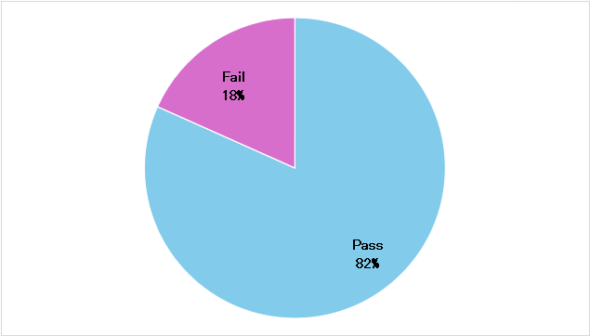
Image 34: Test Case Report Chart

3. Defect Report
During the execution of 71 test scenarios for the GoShop system, the team recorded a total of 13 defects. These defects have been categorized by severity and module to assist the development team in establishing an appropriate remediation plan.

  - Defect Statistics by Severity
The team classifies defects based on their impact on the user's business processes:
Critical: Defects that disrupt core business flows, impact revenue, or compromise data consistency.
Major: Functional defects where the system does not operate as expected, but a workaround is available.
Minor: UI/UX issues or minor notification errors that do not affect the underlying system logic.
Table 32: Defect Statistics by Severity
Severity | Quantity | Percentage (%) | Characteristics
Critical | 4 | 31% | Payment failures, Google Login errors, and order creation during out-of-stock conditions.
Major | 6 | 46% | Phone number boundary value errors, order search malfunctions, and redirection (Redirect) issues.
Minor | 3 | 23% | Cart synchronization display issues and UI update delays after deletion.

  - Detailed Defect Log
The table below documents all 13 defects identified during the test execution of the GoShop system. These defects represent logical vulnerabilities and data inconsistencies that must be remediated prior to official deployment.
Table 33: Detailed Defect Log
No. | TC ID | Module | Defect Description | Actual Result | Severity
1 | AUT-004 | Auth | First-time Google Login. | No new user record is automatically created in the Database. | Critical
2 | AUT-005 | Auth | Post-login Cart. | Products added before login are not automatically merged into the User's cart after a successful session starts. | Major
3 | AUT-006 | Auth | Post-login Redirection. | System redirects to Home instead of the previous Product page.token error occurs. | Major
4 | AUT-016 | Auth | Accessing protected pages after logout. | User can no longer access pages requiring authentication after logging out. | Major
5 | CART-006 | Cart | Syncing upon Admin product deletion. | Product remains in User's cart despite being deleted from the system. | Minor
6 | ODM-005 | Order | Search order by ID. | System returns "Not Found" even with a correct ID input. | Major
7 | STAT-008 | Stats | Admin selects multiple charts for statistical comparison. | The system doesn’t allow selecting and displaying more than 2 charts simultaneously for data cross-referencing. | Minor
8 | ACC-010 | Account | Phone number length boundary (Upper). | System allows saving phone numbers with 12 digits. | Major
9 | ACC-011 | Account | Phone number length boundary (Lower). | System allows saving phone numbers with only 8 digits. | Major
10 | ACC-013 | Account | User updates profile picture with a non-image file format (e.g., .pdf, .docx, .txt). | The system accepts non-image files and attempts to save them as profile pictures instead of blocking the upload. | Minor
11 | CKT-004 | Checkout | Real-time inventory check. | Payment succeeds even after Admin sets inventory to zero. | Critical
12 | CKT-007 | Checkout | Race condition: Two users simultaneously purchase the last remaining item in stock. | The system processes both transactions successfully, resulting in negative inventory (overselling). | Critical
13 | CKT-008 | Checkout | Webhook with an invalid signature (security verification). | The system allows the request and create an order. | Critical

3.3. Detailed Root Cause Analysis and Remediation Methodology
After recording the aforementioned defects, the team conducted a technical session for Root Cause Analysis (RCA) and established a comprehensive remediation workflow.

A. Root Cause Analysis
The team identified that the defects primarily originated from three main technical factors:
Concurrency and Data Synchronization Issues: Specifically seen in CKT-004 and CART-006. The system failed to verify the Final State of data at the exact moment of execution. This led to users interacting with Stale Data that had already been modified by the Admin in the background.

Insufficient Multi-layer Validation: Defects such as ACC-010 and ACC-011 occurred because the team focused heavily on UI validation while lacking strict Constraints at the DTO (Data Transfer Object) layer on the Backend. The absence of maxLength and minLength controls allowed invalid data to persist in the Database.
Incomplete Exception Handling: Errors AUT-004 (Google Login) and CKT-007 (Stripe) indicated that failure scenarios from Third-party APIs were not properly caught and handled. This resulted in system freezes or incorrect status responses to the user.

B. Defect Resolution Workflow
To resolve these issues, the team implemented a rigorous 5-step process:
Triage and Prioritization: Critical defects (Payment, Login) were assigned the highest priority (P1), requiring resolution within 24 hours. Minor defects were categorized as UI improvements (P3).
Isolation and Reproduction: Developers utilized "Test Data" from the Test Cases to reproduce defects in a Local Environment. Debuggers were used to trace the data flow from the Controller down to the Repository layer.
Technical Fixing:
Inventory Defects: Implemented Database Locking mechanisms combined with real-time inventory re-verification at the start of Stripe transactions to prevent Race Conditions.
Validation Defects: Applied a Defense in Depth model by integrating the class-validator library on the Backend and synchronizing Regex patterns on the Frontend.
Confirmation Testing: Once a fix was deployed, Testers re-executed the previously failed Test Cases. If the result was Pass, the defect status was updated to "Closed".

Regression Testing: This critical step involved re-running a Smoke Test suite of the 15 most vital scenarios to ensure that fixing "Payment" did not break "Cart" or "Order" functionalities.

C. Residual Risk Assessment
Despite the remediation efforts, risks regarding network latency during communication with Stripe or Google OAuth APIs persist. The team proposes future integration of Logging & Monitoring systems (such as Sentry) to detect and alert on errors in real-time during production, thereby minimizing service Downtime.

4. General Conclusion
Through a comprehensive testing process ranging from unit to system levels, the team has gained profound and objective insights into the current quality of the GoShop system. Based on the statistical data and analysis presented in Chapter 5, the team draws the following conclusions:

4.1. System Maturity
The system has achieved a high Test Coverage of 100% regarding critical business functions. A Pass rate of 81.7% indicates that GoShop has established a robust framework, effectively meeting the core requirements of an e-commerce platform—from product search and cart management to online payments. The stability of the Product Category (CAT) and Statistics (STAT) modules is a highlight, proving that data processing and visualization are now well-stabilized.

4.2. Existing Challenges
Despite the positive results, 13 defects remain, including 4 Critical issues. These defects primarily center on data synchronization scenarios and third-party API integration. This reflects the reality that in a production environment—characterized by network latency and simultaneous user actions—the system requires more powerful data protection mechanisms, such as Database Locking or middleware Re-validation.

4.3. Deployment Readiness Assessment
Based on the Acceptance Criteria:
Functional aspect: The system is Ready for the limited Beta Testing phase.
Data security aspect: A Fix is required immediately for defects related to inventory management and Google authentication before full-scale official deployment.

4.4. Development and Optimization Roadmap
In the near future, the team will focus on the following plans to optimize GoShop:
Total Remediation of the Defect Log: Prioritizing the Checkout flow and order status synchronization.
Expansion of Testing Scope: Enhancing Non-functional testing, specifically Security Testing to prevent SQL Injection, and more rigorous Performance Testing utilizing the pre-established k6 scripts.

